The many uses of the wooden shoe and its proper application

Stephen E. O’Grady, DVM, MRCVS
Author’s address: Virginia Therapeutic Farriery, 833 Zion Hill Rd, Keswick, Virginia 22947 e-mail: sogrady@look.net
Introduction
There are many practical farriery options available to the clinician when an alternative to a horseshoe may be necessary or preferred. The wooden shoe is a simple, practical and very effective farriery option for treating not only chronic laminitis but many other foot problems (Figure 1) ^{1,2,3 4,5,6,7}. Among those problems that may benefit from the wooden shoe are acute / chronic laminitis, extensive white line disease, fractures of the distal phalanx / navicular bone and horses that have feet with poor hoof wall growth combined with thin deformable soles. The wooden shoe is used as a transitional device to stabilize the hoof capsule, promote hoof wall growth at the coronet and increase sole depth. Once the structures of the hoof capsule have improved with sufficient mass to achieve stability and realignment of the distal phalanx within the hoof capsule in the case of chronic laminitis, conventional farriery is used or the horse can be left barefoot. The wooden shoe is simple to apply; however, there is a learning curve that makes it is essential to follow a procedural model. Understanding the principles of the wooden shoe, the appropriate foot trim, proper fit and placement on the foot and its application are essential. It must be stated from the onset, that the application of the wooden shoe must be combined with the appropriate foot trim to achieve consistent effective results from this modality. The wooden shoe has been popularized treating chronic laminitis, so it’s use here will be used as a model when describing the overall procedure.

Advantages
The wooden shoe has all the mechanical components that can be incorporated in other farrier methodology previously described yet it may possess some additional advantages over previous methods. A major advantage of the wooden shoe is its ability to concentrate the load (weight) evenly over a specified section of the foot due to its flat solid construction ^{1, 2, 3,4,7}. Impression material added to the solar surface of the foot increases the surface area of the foot further enhancing the effects of placing one flat surface against another. Another advantage is its non-traumatic application that eliminates the necessity to use local anesthesia in the case of chronic laminitis or other painful foot conditions. The wooden shoe is constructed from readily accessible materials (wood) or can be purchased commercially ^{c}. Breakover and heel elevation can be fabricated into the shoe and the beveled perimeter of the shoe appears to decrease torque on the lamellae by moving the ground reaction force axially. The beveled perimeter of the shoe also concentrates the load (weight) under the distal phalanx due to the solid base of the shoe. Heel elevation, when necessary, can be applied in a uniform manner by altering the shape of the wooden shoe or by attaching a degree pad to the foot surface of the shoe. The shoe can be easily altered using radiographic guidance plus the biomechanical or structural requirements of the individual foot conformation.
Mechanism
There are three basic principles used in applying therapeutic farriery. The first is to
redistribute the load (weight of the horse) or decrease the forces on a section of the ground surface of the foot. Secondly, to reposition breakover and lastly, to provide heel elevation when necessary to decrease the tension in the deep digital flexor tendon (DDFT). These three principles are especially relevant when treating chronic laminitis. To understand these principles, it is necessary to briefly consider foot biomechanics and the moments about the distal interphalangeal joint. In a standing horse, the weight of the horse borne by the limb (mass times acceleration of gravity) exerts a force on the ground which is opposed by an equal and opposite force, the ground reaction force (GRF). The point at which the GRF acts on the foot is termed the center of pressure (CoP). The position of the CoP varies dependent on foot conformation and trimming but will be located dorsal to the center of rotation (COR) of the distal interphalangeal joint (DIPJ). The GRF being dorsal to the COR creates a moment about the distal interphalangeal joint termed the extensor moment. The extensor moment must be opposed by an equal and opposite moment, which is termed the flexor moment. A moment is the tendency to cause a body to rotate about an axis which in this case, is the center of rotation of the distal interphalangeal joint. At rest, the extensor moment is the product of the weight borne by the limb (a force) and the horizontal distance from the point at which the ground reaction force acts on the foot (COP) and the center of rotation of the distal interphalangeal joint. The flexor moment opposes the extensor moment and is the product of the force in the tendon of the distance of the DDF from the center of rotation and the force (tension) in the tendon and the shortest distance of the DDFT from the COR (Figure 2A). The GRF determines the load and subsequent compressive and tensile stresses that are placed on the dorsal section of the foot. The weight or GRF on the foot cannot be changed, but the position of the GRF where it acts on the ground surface of the foot can be shifted away from the affected area or redistributed. At mid-stance and breakover, the flexor moment exceeds the extensor moment and the GRF moves dorsally in the toe placing pressure and a distractive force in the dorsal section of the foot (Figure 2B). The thickness of the wooden shoe allows breakover to be placed in the shoe further palmarly than conventional shoes. This reduces the extensor moment, brings the GRF closer to the weight force and reduces tension in the DDFT (Figure 3A). This concept can be clearly demonstrated by creating a bevel in two pieces of wood that are of different thickness (Figure 3B). Furthermore, the bevel around the perimeter of the wooden shoe moves the GRF axially which decreases the force required to breakover in a medial or lateral direction with less stress on the tissues (Figure 4). Finally, when the wooden shoe with its firm flat surface is applied to the foot, the distribution of force becomes much larger because weight bearing is distributed over a larger area on the solar surface of the foot. Therefore, combined with the appropriate trim and impression material placed in the frog sulci, one firm flat surface (the foot) is being placed against the other (the shoe).
Construction of the shoe
The author prefers wood due to its accessibility, light weight, the ease with which it can be constructed / shaped (both before and after application) and its ability to dissipate energy at impact while remaining rigid ⁷. There are shoes available commercially that have an ethyl vinyl acetate (EVA) pad substituted for the thicker ¾ inch section of plywood that is beveled. EVA is an extremely elastic material that can be sintered to form a porous material similar to rubber, yet has resilience. The compressibility and wear-ability of this material allows “selective” loading on the ground surface of the shoe relative to the load placed on the limb but this loading is not always in alliance with the appropriate biomechanics to counteract the abnormal forces. The wooden shoe is constructed using an aluminum shoe with a broad toe that is available in sizes 00 to 5 as a template ª. The basic shoe is made from two pieces of plywood. One piece of plywood is 1/4 to 3/8-inch-thick and the second piece is 3/4 inch thick. Using the aluminum shoe as a template, the thinner piece of plywood is cut out with a vertical border while the thicker piece is cut out with the border straight or beveled at a 30-degree angle across the palmar or heel section and a 45° angle around the perimeter of the block using an angle saw ^{b} (Figure 5A). The straight or decreased angle across the palmar section of the shoe prevents rocking backwards during landing. The two pieces of plywood are glued together with the thinner portion proximal and then two 1-inch drywall screws or wood screws are inserted on the foot surface for additional security. A wood rasp or belt sander is used to blend the cut angles into a uniform slope. Alternatively, the wooden shoe is available commercially and can be easily modified with a belt sander or a hoof rasp to match the wooden shoe that was described above ^{c} (Figure 5B). Shoe height is dictated by the conformation of the hoof and the amount of displacement (rotation) of the distal phalanx present – i.e., the greater the rotation of the distal phalanx, the more shoe height is necessary in order to achieve a more palmar placement of breakover. If the sole is prolapsed or the distal phalanx has penetrated the sole, a recess can be created in the dorsal surface of the shoe by cutting a half moon shape that mimics the prolapse using a router or a hand grinder to create a trough in the shoe below the area of the sole or bone that has prolapsed. If it is determined that heel elevation is required, the heels can be elevated accordingly by applying a wedge pad to the hoof surface of the wooden shoe. The angle of the wedge is usually 2-3 degrees depending on the amount of heel horn removed during the trim. The wedge pad is attached to the shoe with 1-inch drywall screws or wood screws. An alternative method to raise the heels is to create a wedge in the shoe by cutting the ground surface of the wooden shoe itself at an angle to the hoof surface.
Radiographs
Radiographs are essential when applying the wooden shoe. The lateral view evaluates the distal phalanx and related soft tissue structures of the foot in a dorsal palmar plane while the dorsopalmar view evaluates these structures in a lateral medial plane. High quality radiographs are required to visualize the osseous structures, the hoof capsule and related soft tissue structures in order to evaluate any disease process, hoof conformation, the position of the distal phalanx within the hoof capsule, position of the DIPJ and especially the soft tissue structures. The radiographs are also used as a guideline for trimming the foot as well as positioning and applying the wooden shoe (Figure 6).
The lateral radiograph has always been considered the “gold” standard for evaluating chronic laminitis but it does not allow identification of asymmetrical medial or lateral distal displacement of the distal phalanx ^{2,3,4,5,6}. Therefore, a dorsopalmar (0-degree dorsopalmar) radiographic projection should always be included as part of the radiographic study for either acute or chronic laminitis.
The radiographic features of chronic laminitis are well documented ^{8,9}. The lateral radiograph will allow the clinician to assess the thickness of the dorsal hoof wall, the descent of the distal phalanx within the hoof capsule, the degree of dorsal rotation of the distal phalanx, the angle of the solar border of the distal phalanx relative to the ground, the distance between the dorsal limit of the solar margin of the distal phalanx and the ground, and the thickness of the sole.
The dorsopalmar radiograph will reveal if asymmetrical distal displacement of the distal phalanx on either the lateral or medial side is present and whether the width of the hoof wall is thicker than normal on the affected side.
A useful template can be superimposed on the lateral radiograph and then transferred to the foot for use as a guideline to apply the appropriate trim and placement of the wooden shoe in cases of chronic laminitis (Figure 7).
Application of the shoe
The trim
Prior to the trim, the horse should be observed in motion noting the degree of lameness, if present, in a straight line and on turns. The landing pattern of the horse should be determined; whether the horse lands flat, heel first, toe first or lands asymmetrically on one side of the hoof capsule. The initial step to trim the foot in all cases is to draw a line across the widest part of the foot. The widest part of the foot is located 5-10 mm dorsal to the COR which makes it a good starting point for the trim. Loose exfoliating horn is removed from the frog and the hoof wall is rasped from the middle of the foot palmarly to where the hoof wall and the frog are on the same plane. The amount of heel trimmed will generally correlate with the lateral radiograph. This creates additional ground surface from the middle of the foot to the heels which moves the load in a palmar direction. The toe length is reduced dorsal to the widest part of the foot to create approximate proportions on either side of the line. In most cases where the wooden shoe is used, the dorsal section of the foot will be compromised with limited sole thickness, so the toe length can be reduced using the nippers in a vertical direction according to the radiograph or by rasping the dorsal hoof wall.
A template can also be used as a guide when trimming the case with laminitis. The quarters and heels of the hoof wall are trimmed from the widest part of the foot palmarly to coincide with line 1 drawn distal to the solar margin of the distal phalanx on the radiograph. The solar surface of the foot dorsal to the widest part of the foot is not trimmed. The toe length is reduced from the dorsal hoof wall according to line 2 drawn dorsal to the parietal surface of the distal phalanx. If possible, the ideal end product when trimmed according to the template, will have two different planes on the ground surface of the foot with the heels of the hoof capsule and the frog on the same plane (Figure 8A). This method of trimming redistributes the load to the palmar section of the foot and functionally unloads the toe.
Following the trim, the foot is placed on the ground and the horse is observed to see whether the heel of the foot is touching the ground at rest. In motion, the horse is observed for signs of lameness or if lameness has increased following the trim and whether it lands markedly toe first in a straight line. If any of these signs are present, heel elevation will be necessary to compensate for the increase in tension in the deep digital flexor tendon caused by trimming the heels of the hoof capsule. Heel elevation is easily added to the wooden shoe using a wedge pad (Figure 8B).
Fitting and applying the shoe
The foot surface of a wooden shoe is measured from dorsal to palmar and then drawing a line through the middle of the shoe. The correct size of the shoe is determined by superimposing the line drawn across the widest part of the foot and the line on the shoe over each other; allowing the wooden shoe to extend marginally beyond the perimeter of the hoof capsule and 10-15 mm palmar to the trimmed heel. Using a 1.98 mm drill, multiple guide holes are drilled through the lateral and medial side of the hoof wall beginning at the widest part of the foot and continuing toward the heel. These holes are predrilled from the solar surface of the foot to ensure accurate screw placement in the wall. 3.75 cm course thread drywall or wood screws are placed in each hole on the outer hoof wall and screwed in until just visible on the ground surface of the foot. To recruit the sole, bars, frog, and sulci for weight bearing and increase the surface area, deformable impression material ³ is applied to the palmar section of the foot being careful that the impression material does not extend beyond the bearing border of the foot surface to create pressure. With the foot off the ground, the shoe is now set in place, 2 or 3 of the preplaced screws are drilled into the shoe and foot is immediately placed on the ground to bear weight. This allows the impression material to conform between the palmar section of the foot and the shoe, thus creating two flat surfaces. After the remaining screws are inserted, additional screws can be placed in the wooden shoe against the outer surface of the hoof wall at the heels to act as struts to provide stability and act as an anchor for the casting tape. With the foot on the ground and using a rasp as a straight edge, a vertical line is drawn from the dorsal aspect of the coronary band to the ground, the side of the wooden shoe is marked at the ground surface and then a line is drawn across the ground surface of the shoe (Figure 9A). Setting the breakover to this point in the shoe is easily accomplished by extending the bevel to this line using a hoof rasp with the foot being held in the farrier position (Figure 9B). The line across the shoe is where the breakover point of the shoe should be positioned which will consistently be located just dorsal to the solar margin of the distal phalanx (Figure 10).
Orthopedic felt or impression material is placed across the bulbs of the heels and 2-inch casting tape ^{e} is applied around the perimeter of the foot forming an attachment between the hoof wall, screws and wooden shoe. The casting tape provides circumferential stability which may prevent flaring of the hoof wall during weight bearing that ultimately pulls the sole distally ¹⁰. Horses are radiographed at 4-5 weeks to assess improvement of the soft tissue structures and are ether transferred to conventional shoes or left in the wooden shoes until the desired results are achieved (Figure 11).
Unilateral displacement of the distal phalanx
Unilateral displacement of the distal phalanx in a mediolateral direction commonly occurs as a consequence of overloading one side of the foot or from laminitis ^{2,3,6}. Unilateral displacement can occur in two clinical scenarios. The first context is less recognized where one side of the foot is overloaded and the distal phalanx descends. Here the limb conformation of the horse leads to an asymmetric landing pattern which causes disproportionate loading on one side of the foot. Hoof characteristics would include an offset foot, a sheared heel and decreased growth at the coronet on the displaced side of the foot (Figure 12A). In the second scenario, the horse will have clinical signs of laminitis, radiographic evidence of displacement or rotation in the dorsal section of the foot and the hoof wall on the displaced side will be thickened compared to the contralateral side due to the diseased lamellae (Figure 12B). Based on the apparent asymmetry of the distal phalanx within the hoof capsule visible on radiographs, a clinician's first response might intuitively be to try and correct the asymmetry of the distal interphalangeal joint and the position of the distal phalanx in relation to the ground. This would most readily be accomplished by trimming and or raising the side of the hoof on which the distal phalanx is displaced. However, bearing in mind the compromise lamellae on the displaced side, this practice will increase the weight bearing on the affected side and cause the distal phalanx to displace further in relation to the hoof capsule, along with increased discomfort. Theoretically, the hoof capsule can be stabilized in relation to the distal phalanx by increasing weight bearing on the contralateral side and reducing weight bearing on the affected side. Biomechanically, the weight of the horse is opposed by the GRF which is exerted on the foot at every point of contact. The GRF acts of the foot through the CoP which is typically located in the middle of the healthy foot. The CoP is important because it determines the distribution of stresses within the hoof; therefore, changing the position of the wooden shoe will cause an asymmetrical redistribution of pressure on the ground surface of the foot that will change the CoP (Figure 13A). The author has been successful in controlling mediolateral displacement by setting the wooden shoe wide on the unaffected side ^{2, 3, 6 11, 12}.
The foot is trimmed as described above making sure the hoof wall and frog are on the same plane and that either the lateral or medial hoof wall is not lowered more than the other. Any significant flare on the affected side of the foot is reduced with a rasp from the outer hoof wall and impression material is placed in the palmar section of the foot to make it load sharing. The wooden shoe is fitted to the foot such that it is flush or tight on the affected side and then forms an1/4 - 3/8-inch extension beyond the perimeter of the wall on the unaffected side of the foot (Figure 13B).
Conclusions
The wooden shoe provides another consistently effective farriery option when treating a variety of foot problems especially laminitis. The case selection in this paper deliberately excludes laminitis patients deemed to have a very poor prognosis. The author, and many of his colleagues, contend that, for welfare and ethical reasons, such horses are euthanasia candidates and should not be subjected to additional pain and suffering with little to no chance of success. Horses selected, although painful, were judged to have sufficient integrity of the hoof structures in which to apply the appropriate trim and use the biomechanical aspects of the wooden shoe to get improvement.
Results from the authors practice and consulting service during the last five years treating acute and chronic laminitis, white line disease, distal phalanx fractures and improving the structures using the wooden shoe in a large number of cases showed consistent improvement which was considered a success (Table 1).
Table 1
Acute Laminitis | >10 cases
Chronic Laminitis | >250 cases
White Line Disease | >30 cases
Distal Phalanx Fractures | 3 cases
Improvement of hoof capsule structures | >50 cases
+ / - 70% success rate

Altering the biomechanical forces on the foot with the bevel of the wooden shoe decreases the stress on the lamellae and soft tissues, an effect which is often difficult to produce with traditional shoes. Cutting the perimeter of the wooden shoe at a 45-degree angle or bevel around the circumference of the shoe appears to decrease the dorsal / lateral / medial torque on the lamellae, especially when the horse turns. The flat firm plane of the wooden shoe, combined with the impression material in the palmar section of the foot, allows load sharing across the ground surface of the foot which further decreases the load borne by the hoof wall. This concept of load sharing is very helpful in a horse with compromised foot conformation that has limited viable hoof structures in a given section of the foot. Furthermore, therapeutic shoes are often deficient in providing sufficient breakover and heel elevation due to the physical limits of the particular shoe whereas increasing the height of the wooden shoe allows the desired biomechanics to be fabricated into the shoe. Finally, the wooden shoe provides a simplified method to apply the three principles of therapeutic farriery which are to redistribute the load or forces on the foot, reposition breakover and provide heel elevation when necessary.
Footnotes
^{a.} EDSS Inc, Penrose CO 81240
^{b.} Sears, Roebuck and Co., Hoffman Estates, IL 60179
^{c.} Equicast, Inc. 575 SE Broad Street Southern Pines, NC 28387

^{d.} Equilox, Inc. Pine Island, MN

^{e.} 3M Animal Care Products, St Paul, Minnesota, USA.

References
- O’Grady, S.E, Steward M.L. The Wooden shoe as an option for treating chronic laminitis. Equine Vet Edu 2009;8:272-276.
- O’Grady, S.E., Steward, M.L., Parks, A.H. How to Construct and Apply the Wooden Shoe for treating Three Manifestations of Chronic Laminitis. In Proceedings. Amer. Assoc of Equine Pract 2007 53:423-429.
- Parks, A.H., O’Grady, S.E. Chronic Laminitis. In: Robinson, NE, and Sprayberry, K. ed. Current Therapy in Equine Medicine 7th ed. St. Louis: Elsevier, 2015;869-878.
- O’Grady, SE. Farriery for Chronic Laminitis. Vet Clin N Am Equine 2010;26:2:407-425.
- O’Grady, S.E. How to Treat Severe Laminitis in an Ambulatory Setting, in Proceedings. Am Assoc Equine Pract 2011;57:270-279.
- O’Grady, SE. The proper application of the wooden shoe: An overview. Equine vet Educ. 2019;31….
- Reid, S. R. Impact energy absorbing mechanisms in crushing and indentation of wood. in Proceedings. IUTAM Symp. On Imact Dynamics Peking University Press 1994.
- Redden RF. Clinical and radiographic examination of the equine foot, in Proceedings. 49th Annual American Association of Equine Practitioners Convention 2003;174-185.
- Sherlock C, Parks A. Radiographic and radiological assessment of laminitis. Equine Vet Edu 2013;25:524-535.
- Thomason JJ. The hoof as a smart structure: Is it smarter than us? In: Floyd AE, Mansmann R, eds. Equine Podiatry. Philadelphia, PA; 2007:46–56.
- Parks, AH. Therapeutic Farriery – One Veterinarians Perspective. Vet Clin N Am Equine 2012;28:333-350.
- Eliashar E. An evidence-based assessment of the biomechanical effects of the common shoeing and farriery techniques. Vet Clin N Am Equine 2007;23:425-442.

Figures

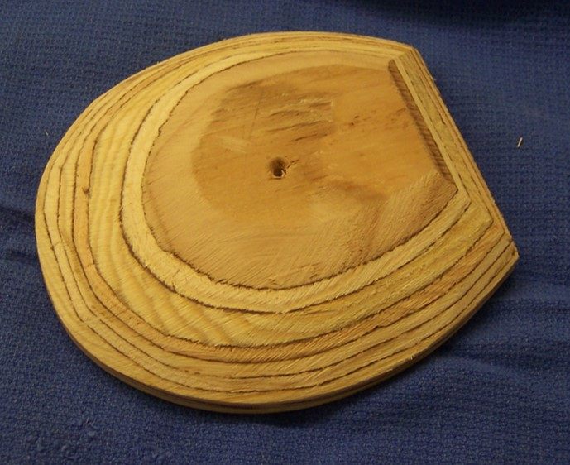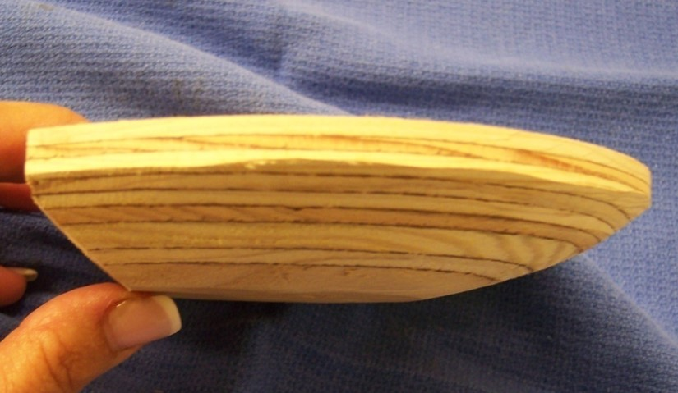
A
B
Figure 1, A) Ground surface B) side view of the wooden shoe. Note the bevel around the perimeter of the shoe and the flat platform on the ground surface.
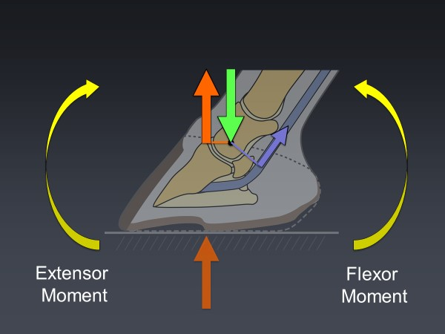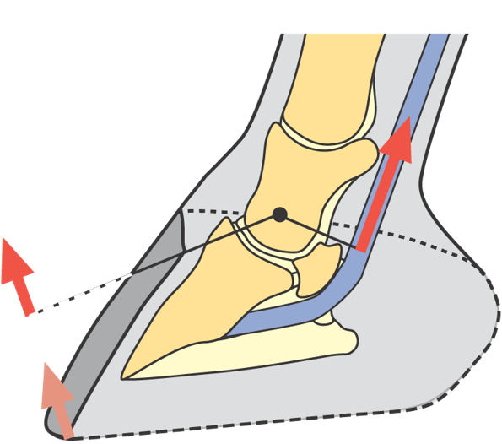
A
B
Figure 2. A) is the biomechanical forces exerted on the foot and the moments about the DIPJ. B) illustrates the GRF moving dorsally in the toe during mid-stance and breakover (Courtesy Andrew Parks)
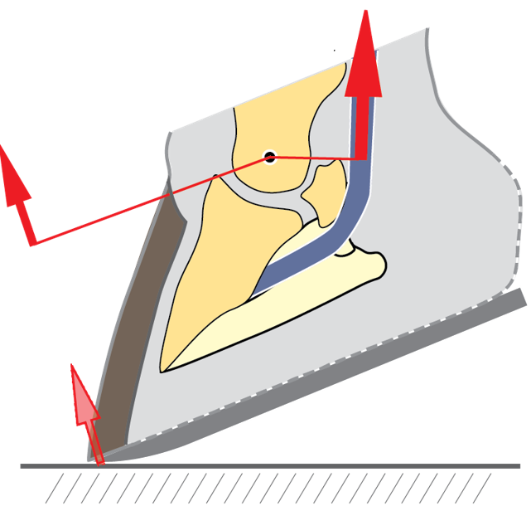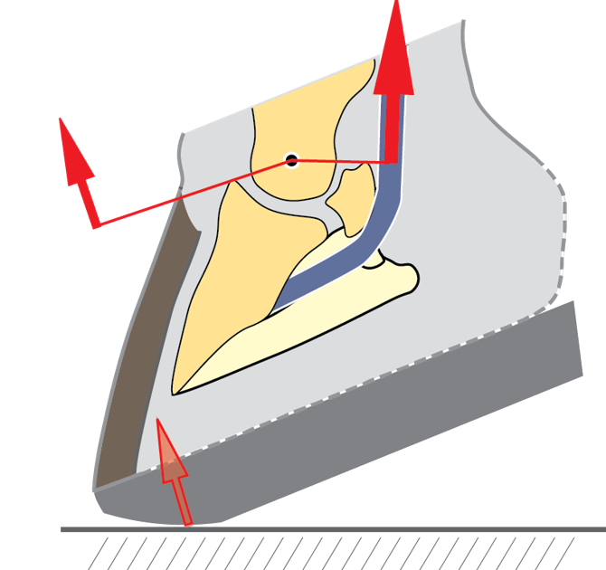
Figure 3A. The extensor moment about the DIPJ can be moved further palmarly in a wooden shoe when compared to a conventional horseshoe (Courtesy Andrew Parks)
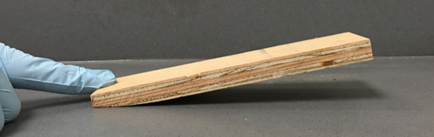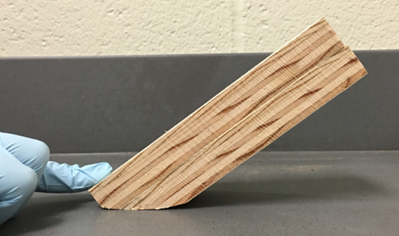
Figure 3B. Illustrates how the tilt (breakover) can be increased when a bevel is created in two pieces of wood of different thicknesses
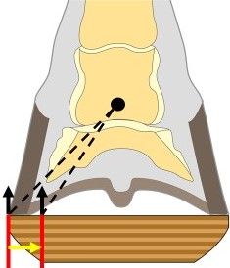
Figure 4 Illustrates the bevel in the wooden shoe that shifts the GRF axially which decreases the moment about the DIPJ and enhances breakover in a mediolateral direction (Courtesy Andrew Parks)
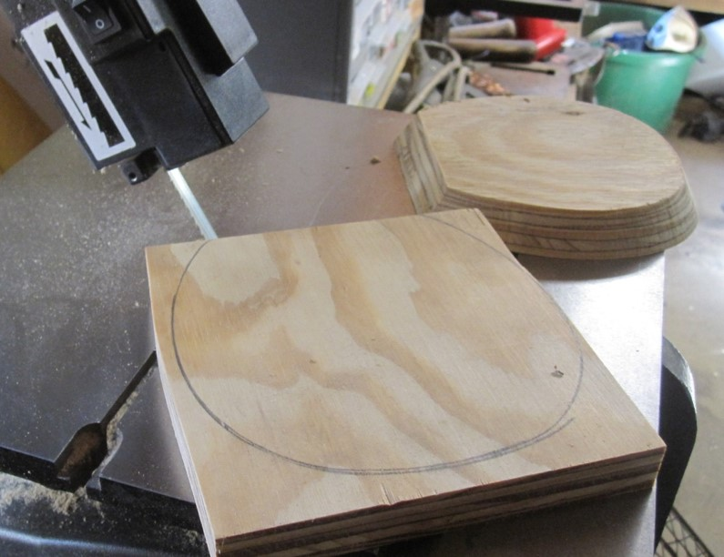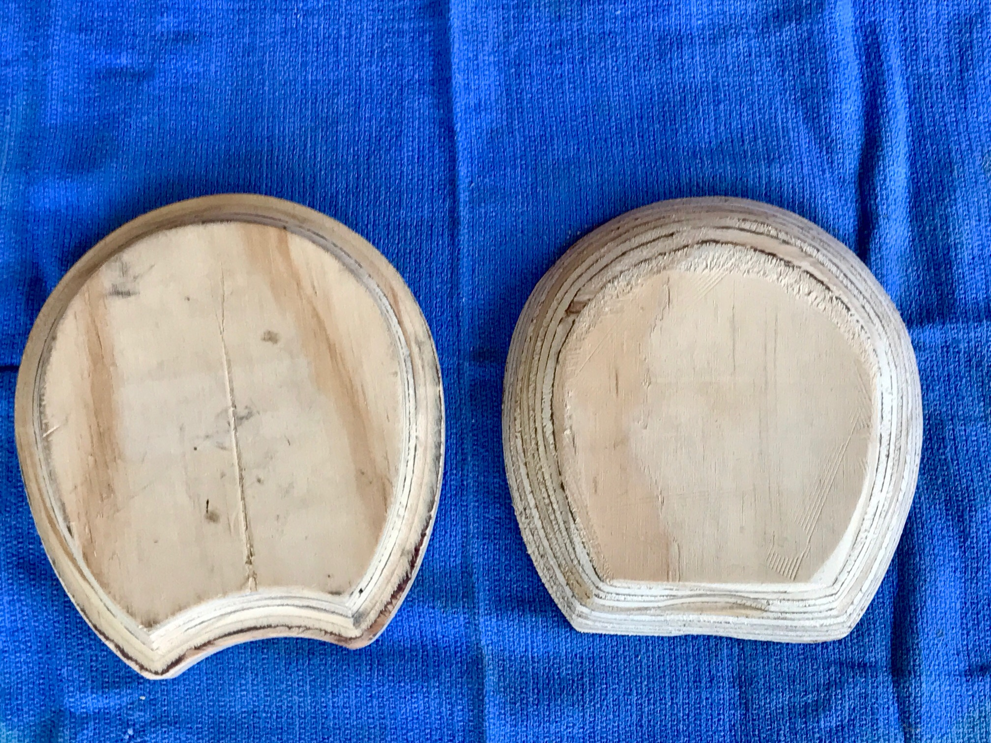
A
B
Figure 5. A) using a template to cut a shoe from a wooden block with a angle saw. B) is a commercially purchased wooden shoe that has been reshaped to create the appropriate bevels using a belt sander or a grinder
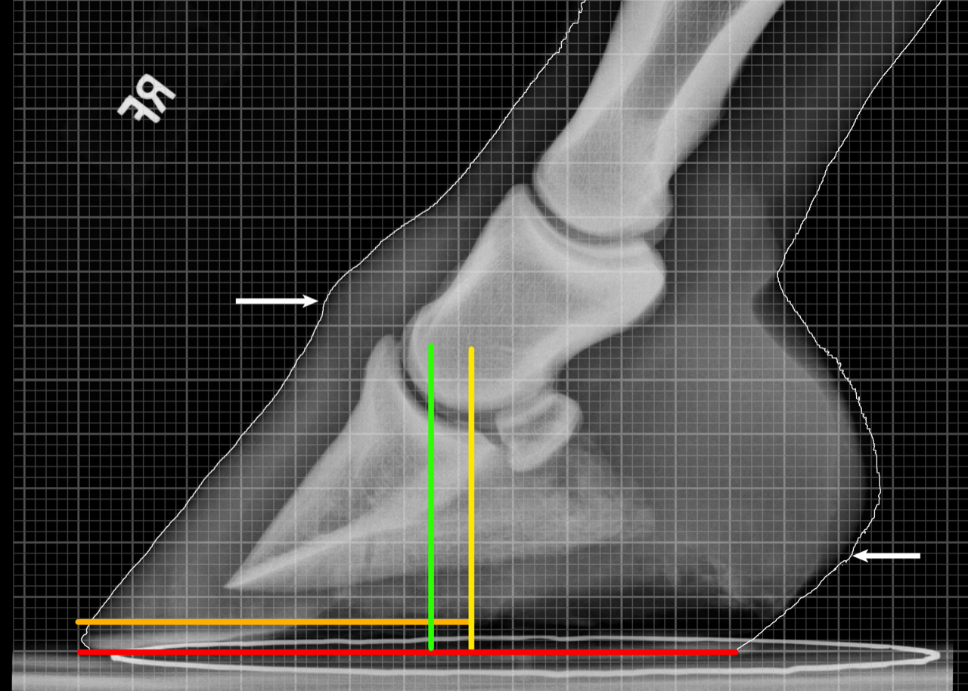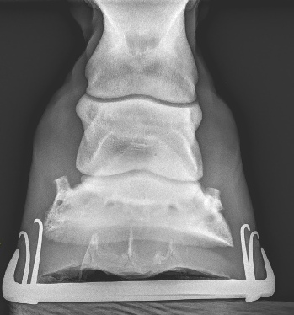
Figure 6 A lateral and dorsopalmar radiograph view. The lateral radiograph shows good foot conformation where the yellow line is the center of rotation and the green line is the widest part of the foot. DP view shows the distal phalanx displaced medially
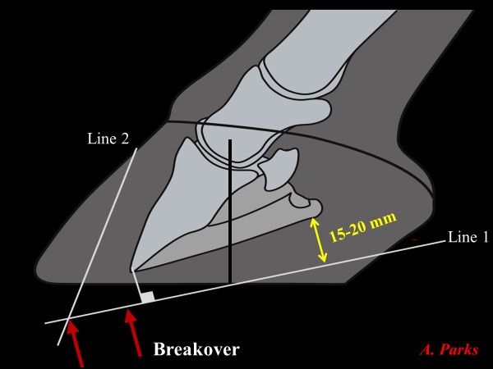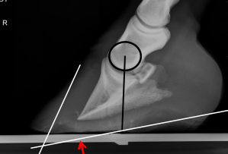
A
B
Figure 7. A) Schematic illustration of a radiograph with dorsal capsular rotation showing the lines drawn parallel to the solar surface of the distal phalanx and the line drawn parallel to the parietal surface of the distal phalanx (Illustration courtesy of Andrew Parks, University of Georgia). B) shows the illustration applied to a radiograph with dorsal capsular rotation. Black line represents COR.

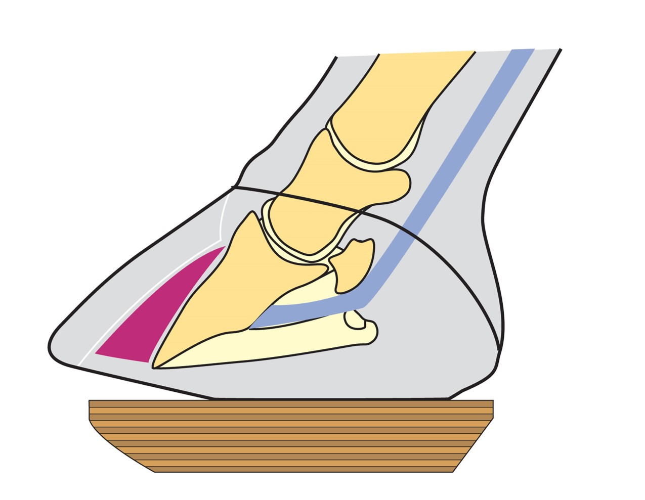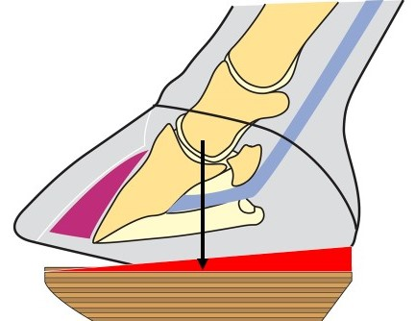
A
B
Figure 8. A) illustrates the two planes on the solar surface of the foot when trimming for realignment of the distal phalanx. Note the position of the block on the foot using the widest part of the foot as a guide to size. B) A wedge pad added to the wooden shoe for heel elevation. (Courtesy Andrew Parks)
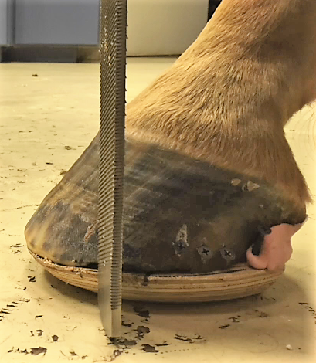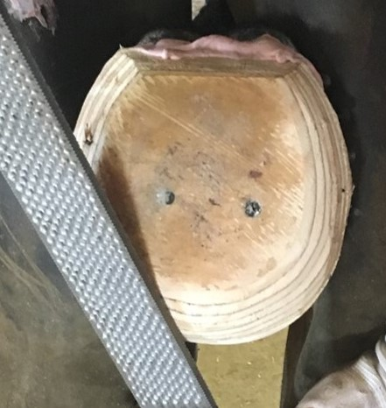
Figure 9. A) shows a rasp positioned vertically dorsal to the coronet to mark the position of breakover. B) shows breakover being created in the wooden shoe with a rasp at the designated point.
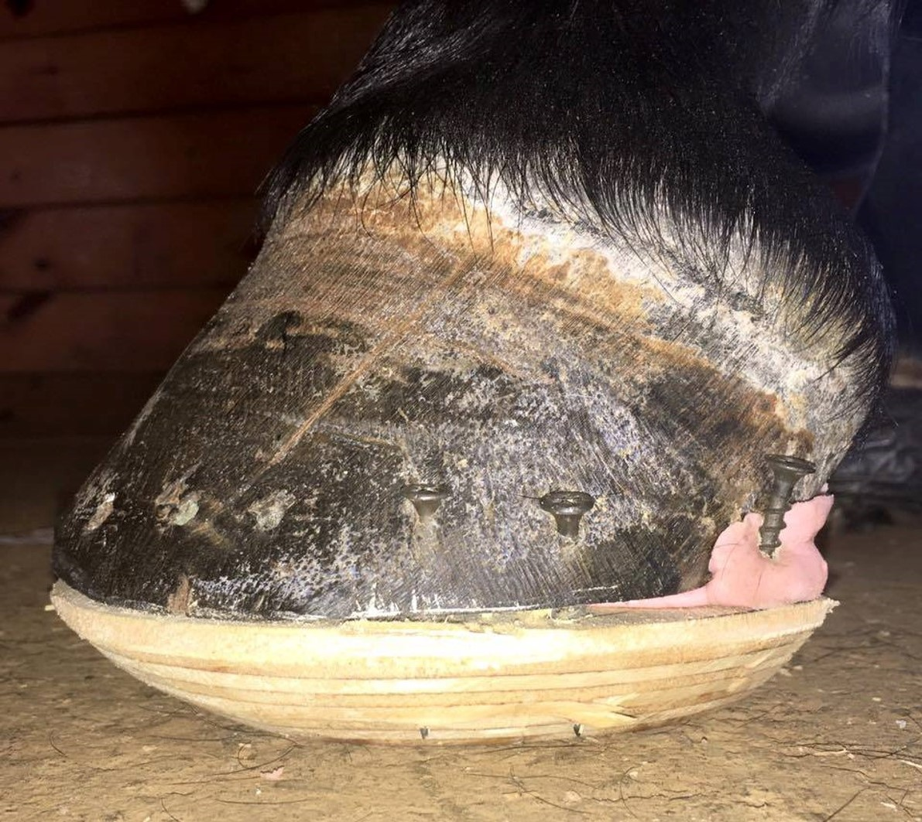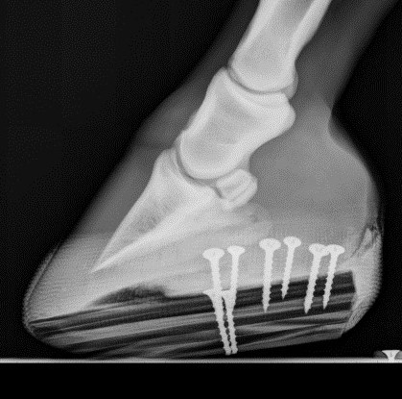
Figure 10 Wooden shoe applied to the foot with corresponding lateral radiograph. Black line is the COR that correlates with the widest part of the foot and red line is the position of breakover. Not the screw placed against the out side of the hoof wall at the heel termed a strut to anchor the casting tape

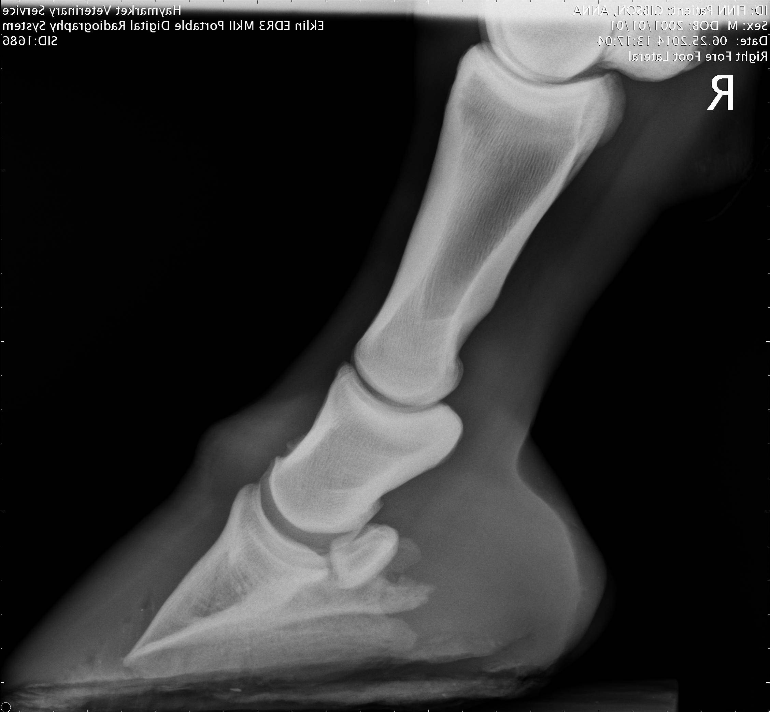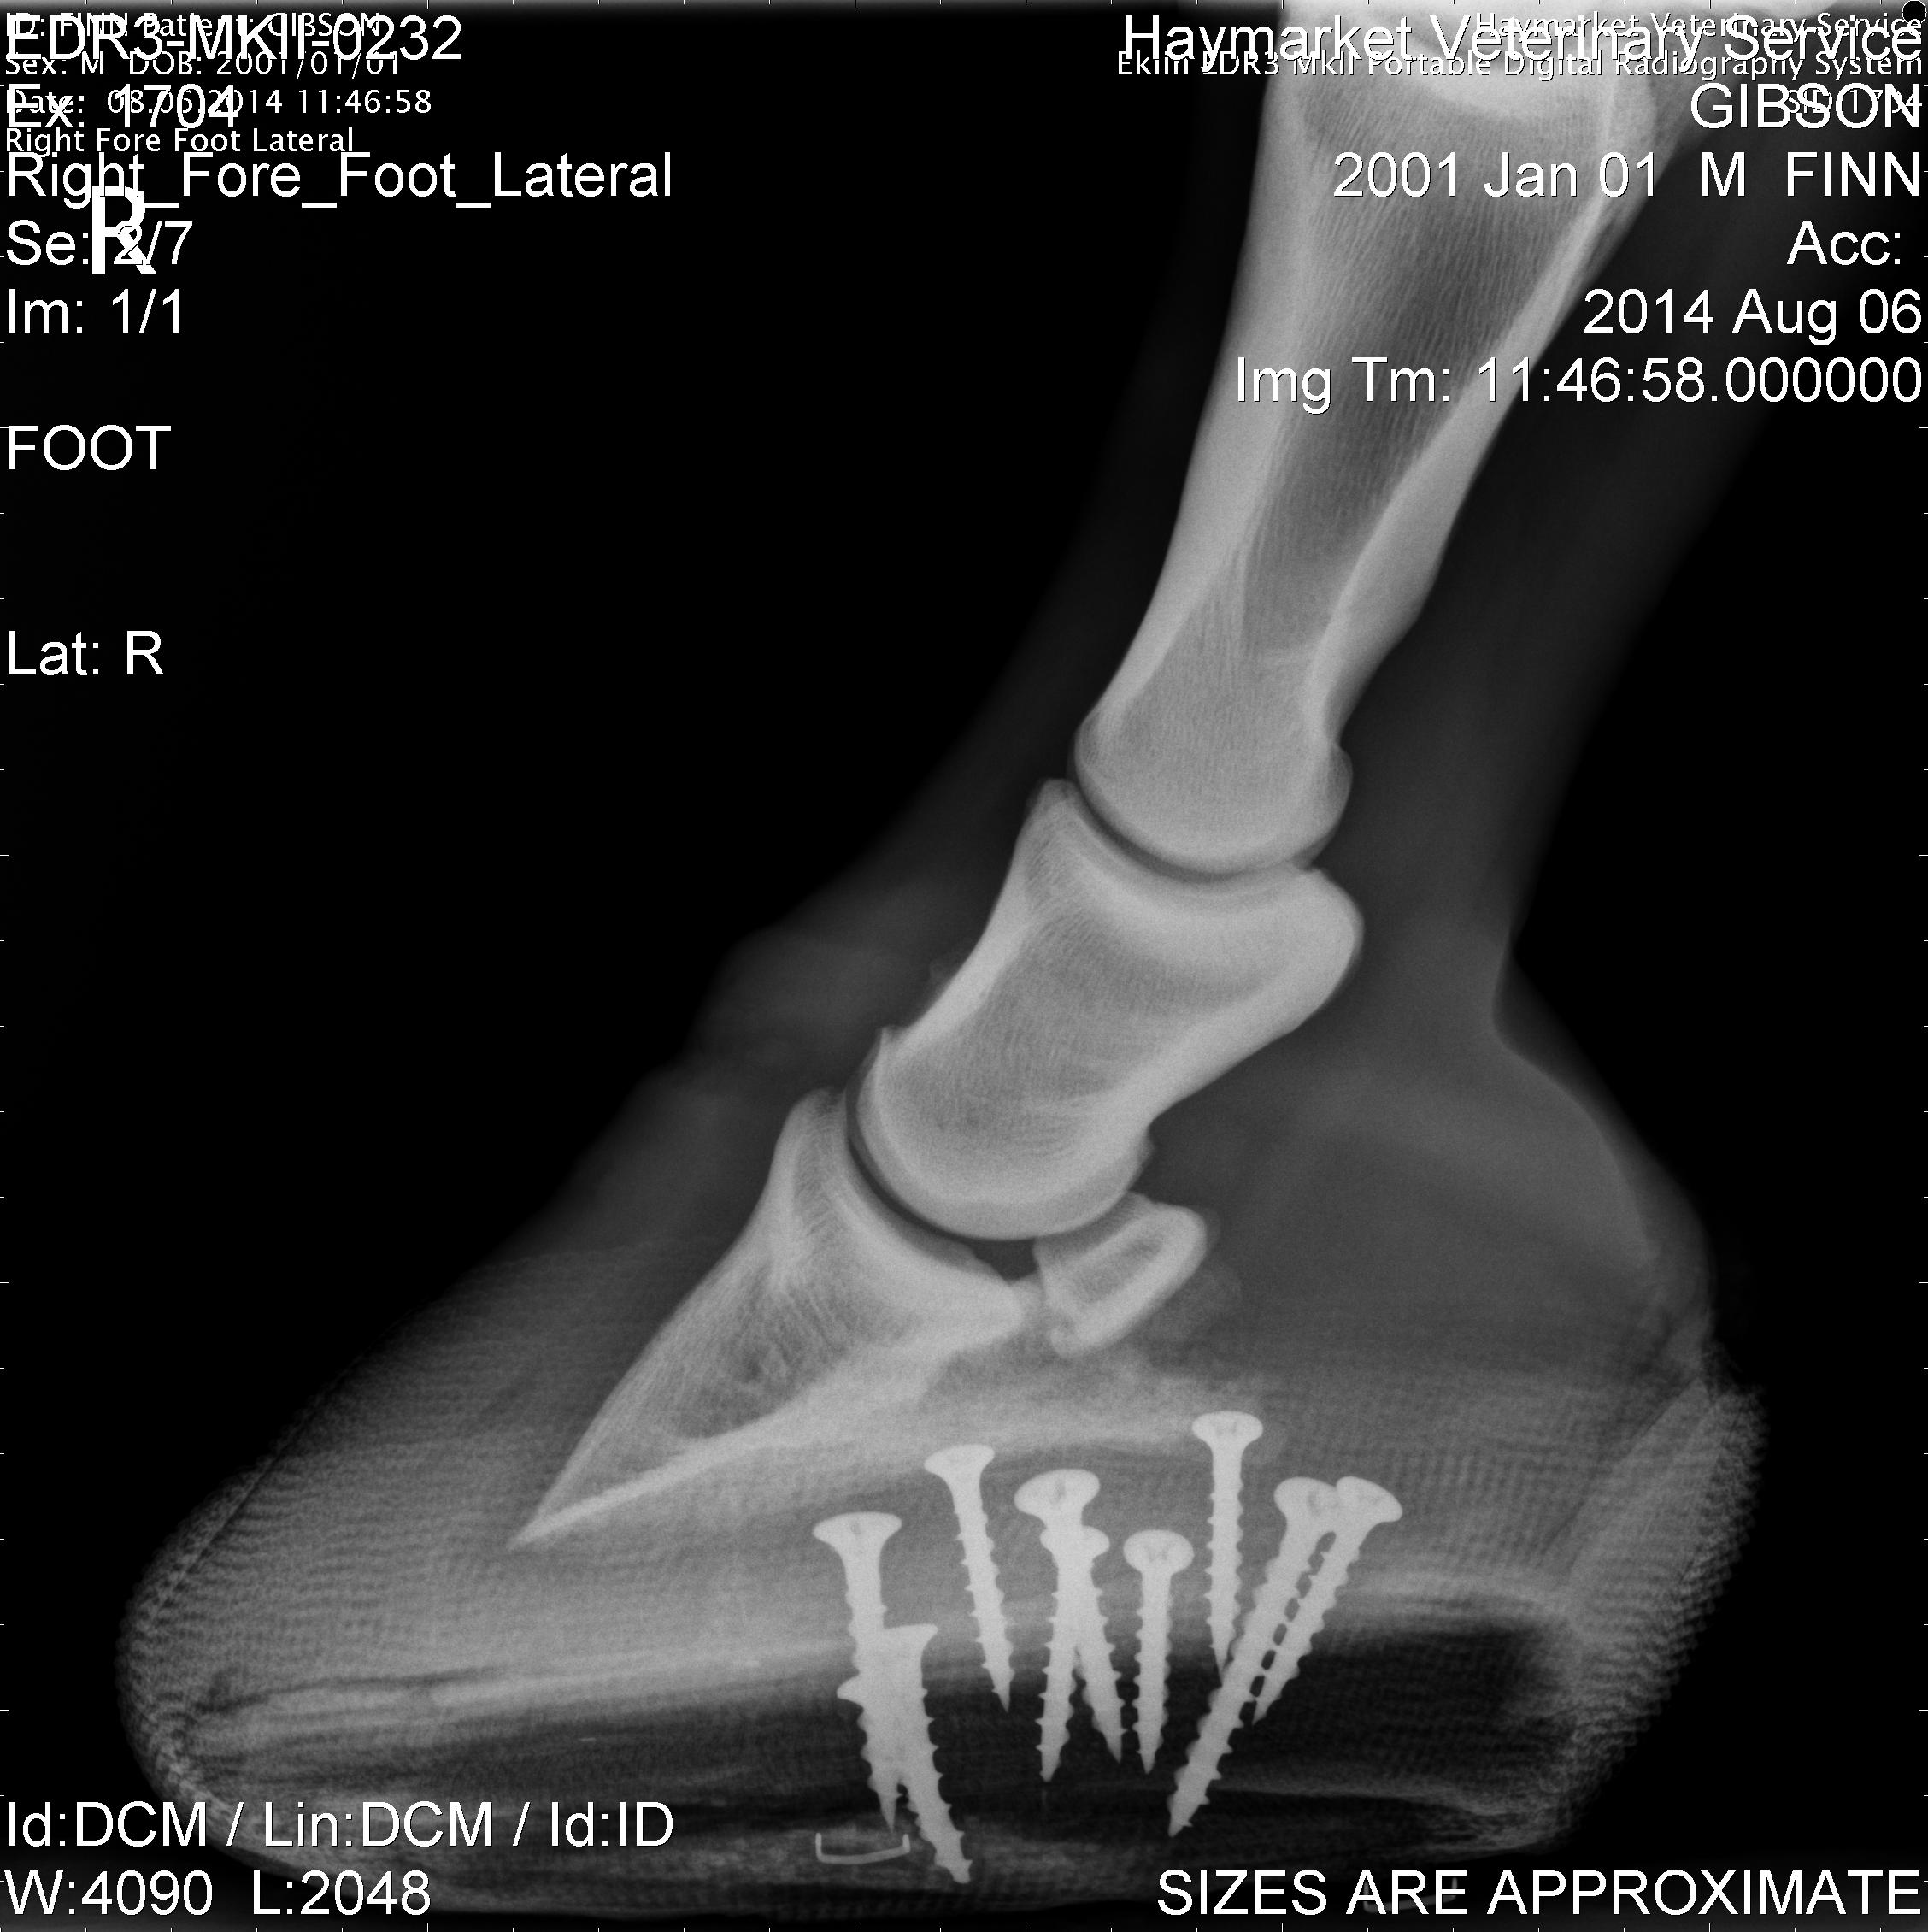
Figure 11. Radiographs show the conformation of the foot before application of the wooden shoe and the change in the soft tissue structures 4-weeks after application
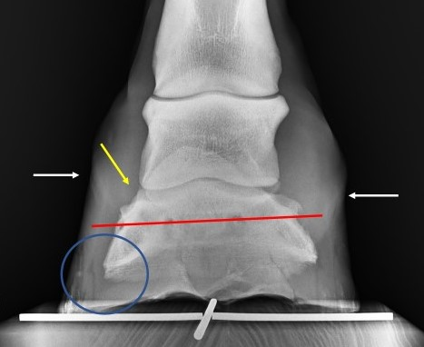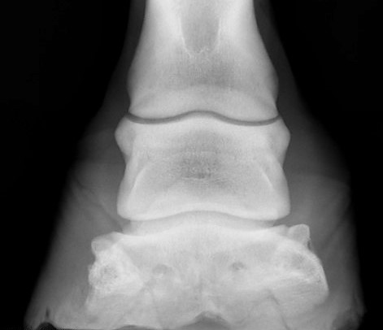
A
B
Figure 12. A0 is a radiograph of a foot with unilateral displacement without laminitis. Red line is the tilt of the bone, yellow arrow is widened joint space, circle is decreased sole thickness and white arrows are position of coronet noting sheared heel on affected side. B) radiograph of unilateral displacement with laminitis. Note the different in hoof wall thickness with the affected side increased.
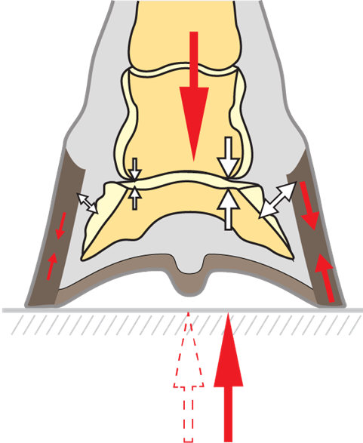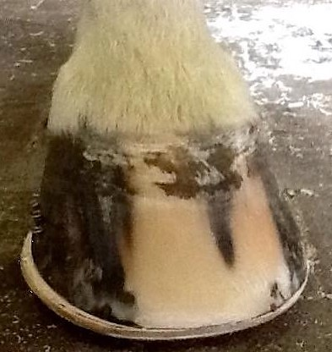
A
B
Figure 13. A) shows the biomechanical concept of moving the CoP (Courtesy of Andrew Parks). B) shows the extension of the wooden shoe on the unaffected side of the foot

