White Line Disease: An Overview

Stephen E. O’Grady, DVM, MRCVS

Author’s address: Virginia Therapeutic farriery, 833 Zion Hill Rd, Keswick, Virginia 22947; email: sogrady@look.net
Introduction
White line disease (WLD) is a disorder localized to the equine foot. The problem is widespread, the etiology and mechanism of the disease are poorly understood and the treatment is often controversial. WLD is a term used to describe a keratinolytic process that originates on the solar surface of the hoof that is characterized by a progressive separation of the inner zone of the hoof wall ^{1,2,3,4,5}. The separation occurs in the non-pigmented horn at the junction between the stratum medium and the stratum internum (Figure 1). The destruction that occurs in the separation as a consequence of WLD remains superficial to the stratum internum and does not invade the dermis. WLD always occurs secondary to a hoof wall separation.
A separation in the hoof wall is considered to be a de-laminating process thought to originate from genetic factors, mechanical stress, inappropriate farriery and / or environmental conditions affecting the inner hoof wall attachment ². The separation, which can originate at the toe, the quarter and / or the heel, appears to be invaded by opportunistic bacteria / fungi leading to an f infection where the organisms digest the horn; this allows the separation to progress to varying heights and configurations proximally toward the coronet.

Anatomy of the hoof wall

A closer look at the hoof wall is necessary to appreciate the location where white line disease occurs.

The hoof wall consists of three layers:
- the stratum externum (external layer);
- the stratum medium (the middle layer):
- the stratum internum (the inner layer).
The stratum externum arises from the perioplic epidermis and forms the thin outer layer of keratinized cells that give the wall its smooth, glossy appearance. The stratum medium, arising from the coronary epidermis, forms the bulk of the hoof wall and is the densest part of the horny wall. It consists of cornified epidermal cells arranged in parallel horny tubules surrounded by intertubular horn, which grow distally from the coronary groove to the basal border. In all hooves the stratum medium is always non-pigmented in the deepest inner layer (Figure 2). The stratum internum arises from the lamellar epidermis, is nonpigmented, and when combined with the dermal lamellae, is responsible for attaching the hoof wall to the distal phalanx. Distally at the sole-wall junction, the dermal lamellae end in terminal papillae. These terminal papillae are lined by a germinal epidermis which generates keratinized epidermal cells; these cells fill the space between the non-pigmented horny laminae as they grow toward the ground surface ⁶. This association forms the bond between the hoof wall and the sole known as the white line or zone. When observed from the solar surface, this white line or zona alba is actually yellow in color and has a plastic consistency when compared to the adjacent dorsal hoof wall.
Etiology
The etiology of WLD remains undetermined. The problem has been diagnosed in horses worldwide. WLD can affect a horse of any age, sex or breed. One or multiple hooves may be involved and the affected hooves can be barefoot or shod. One or multiple horses on the same farm may be affected. It is generally agreed that WLD is a multifactorial condition that develops secondary to an initial separation or hoof wall defect ^{3,4,5}. It must be remembered that multiple causes for white line disease have been proposed, but none have been scientifically proven.
Moisture may play a role as WLD is seen more in wet humid areas but it is also seen in hot arid conditions. Excessive moisture may soften the foot, allowing easier entry of dirt and debris into an existing separation. Continual bathing of competition horses, especially during the warmer months may contribute to the incidence of WLD in this population. Excessively dry hooves, on the other hand, may form cracks or separations in the hoof wall, allowing pathogens to invade.
Poor hygiene has been blamed, but this is questionable since WLD often appears in well-managed stables. Keratinopathogenic bacteria and fungi are commonly isolated from hoof wall defects of horses with WLD, particularly those with more extensive lesions. However, it is generally believed that these microorganisms are opportunistic, secondary invaders that enter the hoof wall through a separation or compromised area, and then exacerbate the hoof wall separation by the production of proteases that degrade keratin. The fact that WLD can be resolved with debridement alone further detracts from this as a primary cause ^{1,3,4,5,7}. Furthermore, there is a large population of horses that have hoof wall separations yet don’t develop WLD; therefore, there appears to be a genetic propensity for horses to develop this condition.
Mechanical stress placed on the inner hoof wall from less than ideal hoof conformation may encourage a separation. Excessive toe length, long toe-low heel and club foot conformation will create abnormal stress in this area.
Vascular hoof damage associated with chronic laminitis results in a compromised bond between the epidermal lamellae and inner hoof wall along with a loss of integrity (separation) dorsal to the sole / wall junction.

Clinical signs
White Line Disease offers no threat to the soundness of the horse until damage is extensive enough to result in displacement of the distal phalanx (rotation). It is common to find WLD as an incidental hoof wall separation found by the farrier during routine hoof care. In the early stages of white line disease, the only noticeable changes on the solar surface of the foot maybe a widening of the sole/wall junction and small powdery areas located just in front of this junction. If the separation becomes more extensive and involves the toe and a quarter, a concavity (“dish”) may be seen forming along one side of the hoof and a bulge will be present on the contralateral side directly above the affected area at the coronary band. To explain this mechanism - the distal phalanx is suspended by the lamellae circumferentially within the hoof capsule in a state of equilibrium. When a substantial separation affecting the epidermal lamellae is present and the laminar attachment is compromised, the equilibrium is disrupted and the distal phalanx will shift toward the separation causing a concavity in the hoof wall on the opposing side of the foot.

Diagnosis
Lameness or hoof capsule abnormalities may not be observed in the early stages of the disease. Hoof tester examination does not always elicit a response. On the solar surface of the hoof, the sole / wall junction (white line) will be wider, softer and have a chalky or waxy texture. Exploring the inner hoof wall, which lies dorsal to the sole / wall junction, will generally reveal a separation filled with white / grey powdery horn material or there may be a black serous drainage from the separation. Further exploration with a blunt probe will give the depth and extent of the cavitation. A hollow sound will be noted when the outer hoof wall over the separation is percussed with a hammer. If lameness is present, a thorough lameness examination should be performed including diagnostic analgesia to localize and confirm the suspected area and then followed by radiographs. Radiographs
Radiography can be very informative and should be considered necessary if the separation is extensive. Good quality radiographs show the extent of the hoof wall separation and whether rotation of distal phalanx within the hoof capsule has occurred. Lateral, dorsopalmar 0 degree and any obliques necessary should be acquired to evaluate the foot. The images allow the clinician to differentiate between white line disease and laminitis. The radiographs can also be used as a guide when trimming and shoeing the horse.
Treatment
Farriery
Improving hoof conformation and correcting any hoof capsule distortion that may have contributed to the hoof wall separation is essential. In order to prevent small separations from becoming extensive, farriers should examine each foot carefully during routine trimming. Separations involving the inner hoof wall should be explored and debrided down to solid horn whenever possible. Any cavity that is left after debridement should be filled with a medicated hoof putty ª before being covered with a shoe.
Treatment of white line disease has to include protecting and unloading the damaged section of the foot with the appropriate farriery combined with resection of the detached hoof capsule overlying the affected area. As a resection disrupts the continuity and weight bearing strength of the hoof capsule, some type of shoe or device should be applied for protection, to stabilize the hoof capsule and to prevent the horse from utilizing the sole for weight bearing. If the separated area of the foot is determined to be extensive, it is important to plan and perform the farriery prior to the outer hoof wall being resected. The type of shoe used and the method of attachment depend on the extent of the damaged hoof wall. If the defect is small, the hoof can be shod with an open shoe paying strict attention to any abnormal hoof conformation. If the defect is large and the overlying segment of hoof wall needs to be resected, some type of bar shoe is indicated to stabilize the hoof capsule. If the separation at the toe and often a quarter becomes extensive, it is necessary to redistribute the weight to the palmar / plantar section of the foot and also move the breakover in a palmar / plantar direction. The shoe is fitted so breakover is placed just dorsal to the margin of the distal phalanx in an attempt to remove the “lever arm” at the toe. This will also stop the “pinching” effect that often occurs at the junction of normal hoof wall and the resection during breakover.
If the resection is to be extensive and / or if rotation of the distal phalanx is present, the foot should be trimmed according to the radiographs and some type of supportive shoe or wooden shoe should be used (Figure 3). This type of shoe allows some weight bearing to be transferred from the hoof wall to the frog (heart bar shoe) or frog, sole and bars (heel plate shoe) (Figure 3). Alternatively, the foot may be shod with an open shoe and the solar surface of the foot between the branches of the shoe is filled with some type of silastic material. If there is limited hoof wall available in which to place nails or shoes cannot be nailed on safely, glue-on shoes may be used. If no rotation is present, a good “rule of thumb” is that if greater than 1/3 of the overall surface area of the hoof is resected, use palmar/ plantar support. If necessary, attaching glue-on shoes to the ground surface of the foot is another useful method for shoeing the horse with WLD ⁸. Foot casts and various types of boots have become popular in treating WLD especially after a resection has been performed, but in the author’s, opinion should be avoided as casts tend to cover the affected section of the foot and boots create a continuous moist environment.
Resection
Complete hoof wall resection and debridement of all tracts and fissures in the affected area is necessary. This can be readily accomplished using a loop hoof knife and half-round hoof nippers. The debridement should be continued proximally and marginally until there is a solid attachment between the hoof wall and external lamellae (Figure 4). The clinician should not generally reach blood during debridement.
Topical disinfectants and medications in any form are of no value without resection of the affected hoof wall. A plethora of topical medications have been described for treatment following hoof wall resection but there have been no controlled studies on any product and none have been proven effective. Antiseptics / astringents such as methiolate or 2% iodine are commonly used but may have the most benefit as a dye marker to outline the remaining tracts in the stratum internum. The dye marker will serve as an aid in making the remaining tracts more visible at subsequent examinations and as a guideline during debridement. After thorough hoof wall resection, the affected area can be left open to grow out with debridement at frequent intervals. A wire brush is used daily to keep the resected area clean. Thorough exploration and debridement of any remaining tracts should take place at 2-week intervals. When the resection has grown out, a thorough examination of the sole / wall junction is imperative at re-shoeing intervals of 4 to 5 weeks.
Acrylic repair of the resected area should be avoided if possible. It should only be considered in selected cases where the client is unable to treat the resected area and where cosmetics are a necessity. If a repair is applied, there should be a significant interface between the composite and the stratum externum. The composite ^{b} may hide and / or foster infection and it tends to weaken the surrounding solid hoof wall - all of which can encourage re-infection.
Aftercare
A change in environment is important. The feet should be kept as dry as possible throughout the recovery period. Sawdust or wood shavings appear to dehydrate the feet making them the bedding of choice and the bedding should always be kept clean and dry. Limited turnout in rain or wet weather is helpful. Turnout can be delayed in the morning until the sun has dried the dew from the pasture
Commitment from the owner with regards to a continuous treatment schedule is necessary until all signs of disease have been eliminated and then the foot / feet must be monitored monthly until the hoof wall grows out. The extent of the damage will determine the approximate amount of time required to complete the treatment process.

Prevention
Prevention of WLD is difficult because the exact cause is unknown. Discussing the problem with the farrier and having him / her examine each foot when the horse is shod is extremely important. Any small abnormal area involving the sole / wall junction should be noted, explored and debrided down to solid horn. Good basic farriery is essential for creating and maintaining a strong sole / wall junction that may prevent separations and offer protection ⁹. Equally important is the necessity to carefully monitor horses that have previously had white line disease. A year or two after WLD has been successively treated and resolved, it can suddenly reappear in some horses with strong hoof walls that show no previous signs of a hoof wall separation.
References

- O’Grady, S.E. White line disease-an update. Equine vet Educ. 2002;14(1):51-55.
- Moyer, W. Hoof wall defects: chronic hoof wall separations and hoof wall cracks. In: O’Grady SE, ed. The Veterinary Clinics of North America, Vol. 19:2. Philadelphia: W.B. Saunders Co, 2003;464-469.
- O’Grady, S.E. How to Manage White Line Disease. In Proceedings. Am. Assoc. Equine Practnr. 2006;51:520-225.
- Pleasant, R.S., O’Grady, S.E. White Line disease. In: Robinson, NE, and Sprayberry, K. ed. Current Therapy in Equine Medicine. vol 6. St. Louis: W. B. Saunders, 2008; 532-534.
- O’Grady, S.E. A fresh look at white line disease. Equine vet Educ. 2011;23(10):517-522.
- Pollitt, C.C. The Anatomy and Physiology of the Suspensory Apparatus of the Distal Phalanx. In: Pollitt CC, ed. The Veterinary Clinics of North America, Vol. 26:1. Philadelphia: W.B. Saunders Co, 2010; 36-37.
- Redding R., O’Grady SE. Nonseptic Diseases Associated with the Hoof Complex. Vet Clin N Am Equine 2012;28:2; 407-421.
- O’Grady, S.E. and Watson, E. How to glue on therapeutic shoes. In Proceedings. Am. Assoc. Equine Practnr. 1999;45: 115-119.
- O’Grady, S.E. and Poupard, D.A. Proper Physiologic Horseshoeing. Equine. In: O’Grady SE, ed. The Veterinary Clinics of North America, Vol. 19:2. Philadelphia: W.B. Saunders Co, 2003;333-351.
Footnotes
- Keratex® Medicated Hoof Putty – Keratex P.O. Box 2, Brookeville, MD 20833
- Equilox® — Equilox Int’l 110 NE 2nd Street Pine Island, MN 55963
Figures

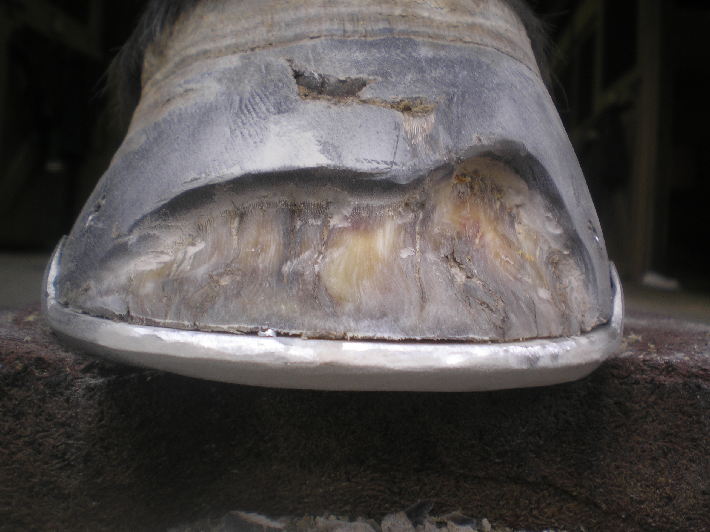
Figure 1. Classic white line disease with separation at junction of stratum medium and stratum internum.

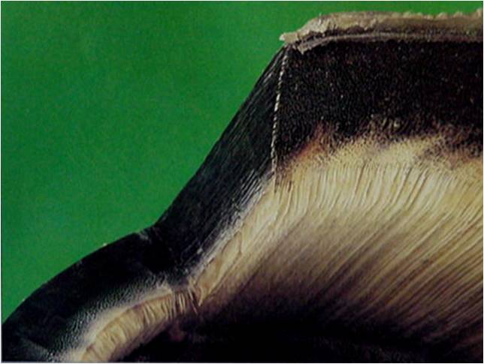
Figure 2. Inner section of the stratum medium (hoof wall) that is non-pigmented. (Courtesy of Dr. Chris Pollitt)
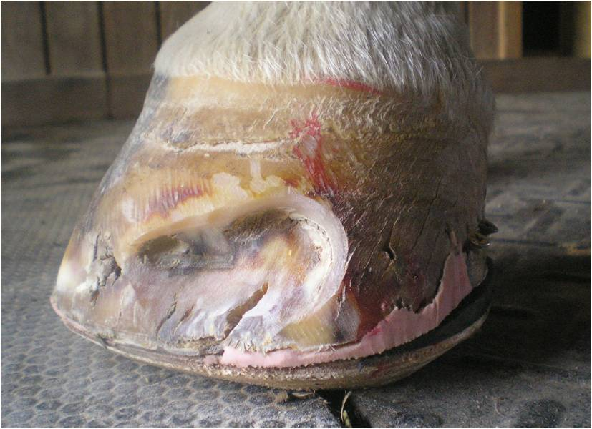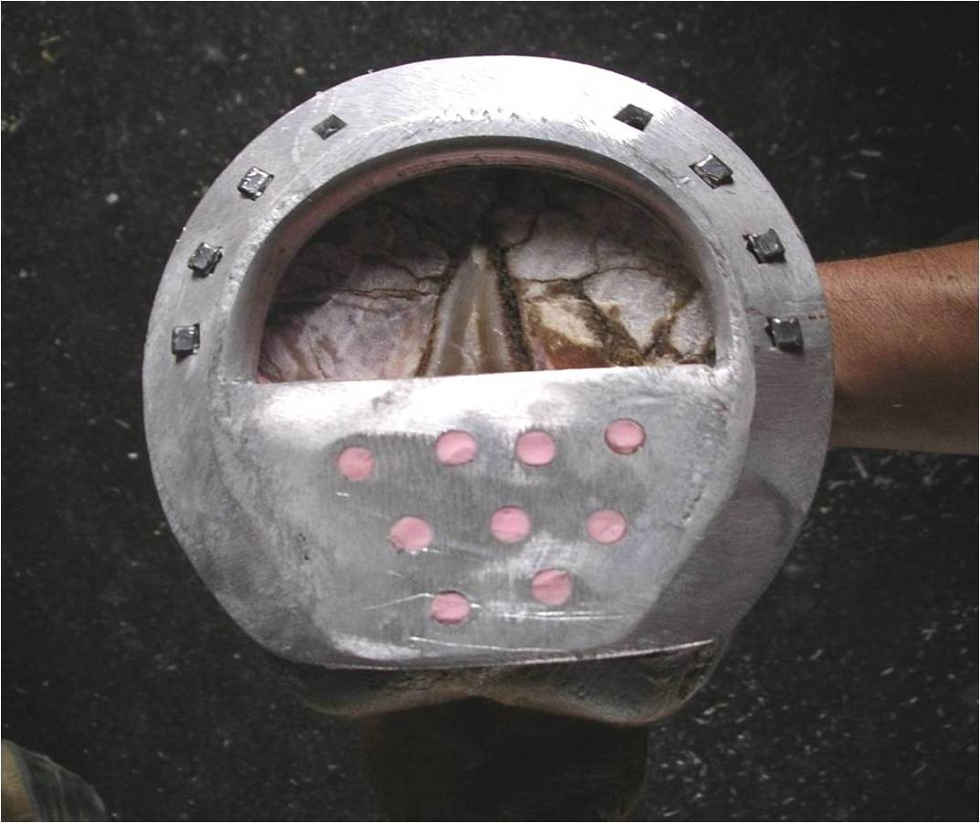
Figure 3. Shoes used to share the weight away from the hoof wall. Wooden shoe and heel plate shoe.
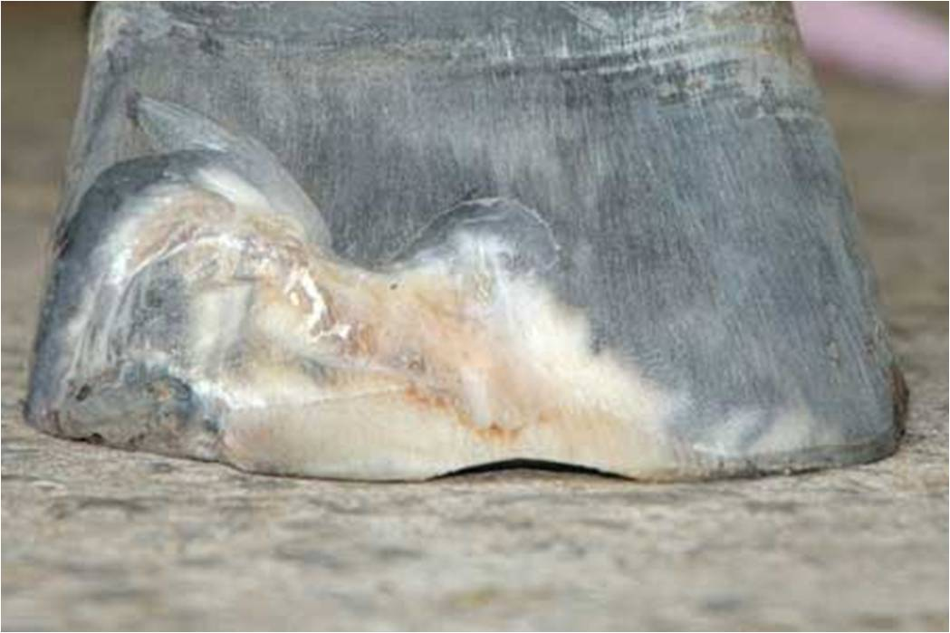
Figure 4. Hoof wall resections. Note the solid margins around the perimeter of both resections.

