Barefoot methodology: a viable farriery option
Stephen E. O’Grady, DVM, MRCVS
Authors address: Virginia Therapeutic Farriery, 833 Zion Hill Rd, Keswick, VA 22947; e-mail: sogrady@look.net
Introduction
The structures of the equine foot have the unique ability to adapt, change shape and restore ^{1,2,3}. The equine foot with healthy structures is superior in its natural or barefoot state as opposed to being shod with regards to accepting the weight of the horse, shock absorption and dissipating the energy of impact ^{1,2,3}. Furthermore, the structures of the foot have an inherent ability to change shape, strengthen and improve over time through the process of adaptation^{1,3}. Barefoot methodology is applied in two practice situations; in shod horses, the shoes are removed for a specified time to rehabilitate distorted hoof conformation before replacing the shoes and secondly, to transition the horse from being shod to barefoot and maintain the feet in the barefoot state. The author has been successful in improving the soft tissue structures in the palmar section of shod horses with a distorted hoof capsule in a growing number of horses by leaving the horse barefoot for a given time frame. The use of traditional farriery or the application of a shoe with regards to the elite athlete or competition horse was considered necessary for performance but recently the approach to traditional hoof care by veterinarians and farriers is being challenged. Following the recent summer Olympics in Japan, where some show jumpers successfully competed barefoot, there has been a renewed interest in this farriery option. Furthermore, the deformable synthetic surfaces that horses compete on today makes this a viable farriery option. This is not to infer that traditional farriery cannot be performed in a proper physiological manner with minimal damage to the horse’s foot ^{4, 5,6}. However, there are many aspects of the barefoot methodology that pose a feasible and practical option to traditional farriery and may warrant consideration. Finally, if a horse is being rehabilitated due to disease or injury, it appears prudent to remove the shoes during this period of recuperation as the health, structures and conformation of the foot are likely to improve. A successful outcome with any aspect of barefoot methodology outlined above requires a different approach to traditional hoof care.

The effect of applying a horseshoe

Shoes are applied to the horse’s foot for protection when wear on the solar surface of the foot exceeds growth at the coronet, for maintaining or enhancing functionality such as traction, and as a therapeutic device to improve compromised structures of the foot and treat disease/lameness. There is little doubt that applying a horseshoe to a horse’s foot will not change the mass and the functionality of the hoof structures. A brief look at the effects of applying a shoe may highlight the potential beneﬁts of being left barefoot or being left barefoot for a brief time. In actuality, the horseshoe is not an extension of the horse’s foot. Placing a horseshoe with different properties than the hoof capsule between the hoof and the ground replaces a single interface with 2 interfaces (Fig 1) ^{7,8}. This change in interface will invariably have consequences on foot function. This interface alters the concussion-dampening effect on the lower limb, which results in an increase of impact intensity on the hoof ^{8, 9, 10}. Applying a shoe elevates the hoof off the ground surface by loading the hoof wall; this elevation results in less heel expansion compared with the unshod foot ¹⁰. A recent paper showed a traditional shoe was associated with significantly less heel expansion compared with a split toe shoe and the barefoot situation in all gaits ¹¹. The weight of the shoe will increase the force exerted on the navicular bone by the deep digital flexor tendon ^{8,12}. The process of hoof growth and wear will often allow the barefoot horse to maintain the shape of its feet as friction and thus wear occurs between the ground and the entire solar surface of the foot. When a horse is shod, friction is localized between the heel of the hoof capsule and the shoe, which induces greater wear at the heel compared with wear at the toe, which, will change the conformation of the foot between shoeing cycles ^{8,11}.

Methodology

The trim
The trim applied to a foot that is to remain barefoot, whether temporary or permanent, will be different from the trim applied to a foot prior to applying shoes. In the author’s farriery practice, the difference in the trim is described as ‘when the horse is to be shod, the foot is trimmed; when the horse is to be left barefoot, the foot is shaped’. The biggest difference is that the horny sole is left intact, and the hoof wall is left 3–5 mm longer which provides as much protection as possible ^{6, 15}. The solar surface of the foot is initially brushed briskly with a wire brush. The hoof knife is generally not required when shaping the foot other than to remove any extraneous, exfoliating horny tissue from the frog. If there is excessive hoof wall to be removed (which generally occurs at the toe), hoof nippers will be used, however, not in the usual manner of cutting horn on the same horizontal plane as the sole. Instead, the nippers are placed in a semi-vertical position at an angle of approximately 45° and the cut is started on the outer side of the sole-wall junction (white line) (Fig 2). The goal is to bevel the bearing surface of the hoof wall and then form a thick rounded peripheral edge. After removal of any excessive horn or toe length, a rasp is used to trim the heels of the hoof capsule in a horizontal direction across the frog just to the point where the heels are on the same horizontal plane as the frog, which makes the palmar section of the foot ‘load sharing’. This will generally extend the heels on the solar surface of the hoof capsule at the widest part of the frog. Starting at the heel quarter, the rasp is now used in a vertical direction at a 45° angle around the circumference of the foot staying on the outer side of the sole-wall junction (Fig 3). The vertical direction of the rasp will create a sharp edge at the distal extent of the bevel which is then removed by laying the rasp against the outer hoof wall surface and rasping toward the bevel with a rounding motion to remove the sharp edge, resulting in a thick rounded perimeter continuous with the outer hoof wall. (Fig 4). Excessive hoof wall ﬂares are removed from the outer hoof wall; followed by using the rasp to blend this area into the rounded perimeter of the hoof wall. Trimming the bearing border of the wall in this manner will also prevent chipping and cracking around the perimeter of the hoof wall. This trimming protocol may seem awkward or cumbersome to farriers as it differs from their usual direction of rasping a foot during a routine trim. Whether the horse is to be left barefoot temporarily or transition to remaining barefoot, it is important to leave all the horn/mass on the solar surface of the foot.
The process

Using barefoot methodology to improve the palmar section of the foot
A distorted palmar/plantar section of the foot, especially the deformable soft tissue structures, are often associated with lameness ¹⁷. The hoof capsule with a sheared heel or low/under run heels combined with a negative angle of the solar border of the distal phalanx are very common foot problems seen in equine veterinary practice. There are many causes for this compromised hoof capsule such as abnormal limb alignment, excessive load on a section of the foot and inappropriate farriery practices. There are many farriery techniques described to address these types of hoof conformation, yet none have shown consistent documented success. Sheared heels are generally caused by abnormal limb or foot conformation which causes an asymmetrical landing pattern when the foot strikes the ground. This repetitive disproportionate load on one side of the foot causes proximal displacement of the heel/quarter of the hoof capsule which along with the increased compressive stresses placed on the submural tissue in the displaced area, predispose the foot to various injurious conditions including a quarter crack. Removing the shoes for as little as five days will redistribute the weight on the bottom of the foot and allow the displaced heel to open and descend to a more acceptable conformation. Furthermore, if a quarter crack is present (the coronet will be displaced proximally at the origin of the defect), removing the shoes allows the coronet to settle into a more parallel position or slope before any type of repair is considered (Fig 5).
In the case of low or underrun heels, the heels are allowed to migrate forward often accompanied by a shoe that is too small, the surface area in the heel area is now decreased which places excessive load on less surface area at the heel which will be located dorsal to the base of the frog. More weightbearing on less surface area decreases heel growth with the frog now situated palmar to the heels of the hoof capsule and prolapsed distally between the branches of the shoe. This is complicated by the heels of the hoof capsule expanding against the surface of the shoe, which further wears the horn at the heels. The author has been able to consistently improve the structures in the palmar foot in horses by taking the horse out of work and giving them time without their shoes. With either sheared heels or low heels, the shoes are removed, and the feet are trimmed as outlined in the protocol above with a few exceptions. When shoes are removed from a horse with under run heels, the frog will generally be located below the level of the hoof wall to the extent that when the foot is placed on the ground, the horse will be standing on his frog alone. The ﬁrst objective is to get the frog and the hoof wall on the same plane so this section of the foot is ‘load sharing’. This is accomplished by the sheer weight of the horse standing/walking on a firm surface during the ﬁrst week of having the shoes removed. Any excessive toe length is reduced by using the hoof nippers across the toe in a completely vertical direction which will preserve all mass on the solar surface of the foot. Usually, the heels can be rasped in a horizontal direction, i.e., the same plane as the solar surface of the foot within 10-14 days, the folded underrun horn at the heels can be removed and the bars and angle of the sole will begin to become apparent (Fig. 6A&6B). The management of the horse during the period without shoes is handled as described for the transition to the barefoot state. If handled properly, the integrity of the hoof wall will improve, and the sole thickness will increase; both of which can be veriﬁed with hoof testers and or radiographs. The amount of time the horse is without shoes varies and is determined by the owner/trainer, farrier and clinician. When shoes are replaced, strict attention is paid to the trim, size type and placement of the shoe using guidelines such as the hoof-pastern axis, the center of rotation and trimming to the base of the frog or to the same plane of the frog ⁵.

The transition from being shod to remaining barefoot
The author has been an advocate of maintaining upper-level competition horses (or any horse) barefoot when this type of farriery is feasible, possible, or desired. Following the recent publicity, many owners and trainers felt this may be a good farriery option. There are many factors/variables to consider when deciding whether a horse is a candidate to leave barefoot. These may include the type and amount of work expected of the horse, surfaces on which the horse will perform, genetics, current hoof conformation, the integrity and mass of the soft tissue structures in the palmar foot, and the structural integrity of the hoof capsule. The severity of any of these factors or combination of these factors may make the horse unsuitable to compete barefoot. When the horse wears shoes, it should be remembered that the hoof is raised off the ground, and the major load is placed on the periphery of the hoof wall. Being above ground, the sole-wall junction, the sole, bars, digital cushion, and frog will lose some structural integrity and mass from lack of stimulation or interaction with the ground due to the interface created by the shoe. Additionally, the sole thickness will invariably decrease with shoes, thus limiting its protective nature. The structures of the hoof capsule have to change density and strengthen through the process of adaptation; therefore, an adequate transition period to allow adaptation of the foot is essential when attempting to change from shoes to barefoot. If the hoof walls are thin and the sole at the toe markedly deforms when hoof testers are applied, the use of a modified hoof cast can be used to assist with the transition as it will add mass, stability, and protection to the hoof capsule during the transition period without interfering with the physiological function of the foot ¹⁸.
Removing the horse’s shoes without a transition period will seldom be successful. The hoof structures need time to adapt, strengthen, change shape, and improve the integrity of the hoof capsule. When the horse is barefoot, all the foot structures will be used to accept weight rather than relying on the hoof wall and the protection afforded by the shoes. With the shoes removed, the foot will adapt relative to the change in the biomechanical forces now placed on the foot ⁸. Horses are selected on having good hoof conformation/structures or the potential for the structures of the hoof capsule to improve and strengthen. Horses with poor hoof structures in the palmar/plantar foot or those with significant hoof capsule distortions are not selected. The shoes are generally removed toward the end of the shoeing cycle which is just before the horse is due to be shod at 4-5 weeks as there will be maximum hoof wall growth on the bottom of the foot. The length of the transition time is dependent on the quality of the hoof capsule structures when the shoes are removed; the author generally recommends that the horse be walked 1-2 times a day (15-20 minutes) on a firm surface for a few days. If the horse remains comfortable hand walking, the horse may be turned out in a small area (paddock or round pen) for a few hours daily and or be ridden through the country on firm footing for the next few weeks. At this time, if sound, the horse is started back to work in an arena setting with deformable footing. The feet are trimmed (shaped) at 3–4-week intervals as outlined in the trim protocol above, ensuring the hoof wall at the heels and the frog remain on the same plane as the palmar/plantar section of the foot needs to ‘share the weight.’ The transition period will depend on the condition of the feet when the shoes are removed and how the horse responds during the transition period to being barefoot. It should be emphasized that boots should be avoided during the transition phase…’ boots are not barefoot.’ Boots place an interface between the foot and the ground, which changes the forces on the foot and interferes with adaptation. The author has had some horses go back to training in as little as three weeks and back to competition in as little as five weeks. This process will further depend on whether the horse goes back to work on a synthetic deformable surface or some type of firmer footing.
Using a modified hoof cast
Applying a modified hoof cast at the onset or during the transition period may augment the process and, in some cases, decrease the time necessary to transition to barefoot ¹⁸. When removing the shoes, the hoof wall condition is one of the critical factors that determines if and how long it takes to transition to barefoot. The hoof wall thickness may be thin, have poor consistency, multiple deep hoof wall separations, cracks around the hoof capsules bearing border, and the heel base (hoof wall, bars, and the angle of the sole) may be collapsed or underrun. Furthermore, there may not be sufficient hoof wall at the bearing border of the foot to allow it to extend a few millimeters distal to the sole. The modified hoof cast affords stability, provides additional mass, and protects the hoof capsule without interfering with any physiological functions or the adaptation process. The cast is applied to the outer hoof wall so that at least 4-5 millimeters of the cast will extend beyond the perimeter of the hoof capsule. The foot is placed on the ground after the cast is wrapped with plastic wrap and begins to cure. The horse's weight causes the excess cast to fold under the foot and form a protective layer of cast material on the solar surface around the bearing border of the foot (Figure 7A&7B). The farrier or the trainer can readily apply the modified hoof cast on a barefoot horse if indicated.
Traction
Most hunters, jumpers, and dressage horses perform on synthetic deformable surfaces, and traction has not presented a problem. However, some jumper or Grand Prix courses are held on the grass, and horses may require additional traction, especially if the surface is wet. The grass is not the routine environment for the barefoot horse to compete, so if a competition is held on the grass, a pair/set of shoes can be fitted to the horse without trimming or changing the solar surface of the foot. The shoes are attached using four nails, and when the horse has finished the class (s), the shoes are removed, and the horse continues barefoot. This scenario requires a little more work on the part of the farrier, but has shown to fulfill the need or necessity for additional traction. Recently, the author observed the horses at a large jumper barn that were training on the grass and the horses showed no slippage or lack of propulsion when jumping or when navigating tight turns.
Observations
When given the opportunity and time, the author has always rehabilitated distorted hoof capsules or poor hoof conformation without shoes and has had consistently good results over the years. Based on the records of seventy horses, fifty of those horses in competition. There were only two horses that could not be transitioned from wearing shoes to barefoot. Both horses that remained in shoes had chronic lameness issues. The average time to improve sheared heels was 7-10 days and generally longer to improve low or underrun heels which usually takes 4-6 weeks. It should be noted that the amount of improvement noted in horses with low heels is dependent on the condition of the soft tissue structures in the palmar foot at the onset. When transitioned from shoes to barefoot, the foot will show a harder hoof wall possibly from moisture or urine not being retained under the shoe, horses will form a sole callus at the sole-wall junction of the toe, a stronger hoof wall bar junction, a thicker broader frog and the foot will change shape with an increased depth (cup/concavity) to the foot (Fig 8).
Conclusions
Success in transitioning horses from shoes to barefoot is based on the veterinarian, farrier, trainer, and owner understanding and willingness to adhere to the entire process. Selecting horses with suitable hoof structures or hoof structures that can improve and strengthen is essential combined with changing the farriery performed on the horse from trimming the foot to the concept of ‘shaping’ the foot. And finally, the transition period is vital as it’s essential to allow the feet time to adapt, strengthen, change shape, and improve the integrity of the hoof capsule structures. The author has had consistent success with this transition from shod to barefoot primarily because of the cooperation of all parties involved. Trainers/ riders state that the strides change on the horse when barefoot, and the clearance over the jumps is markedly higher possibly because different type of horseshoes as cable of causing leverage at the end of the limb. Perhaps one day in the future, these performance changes will be proven. The success this author and others have had with a limited but growing number of horses would seem to imply this is a feasible farriery option when understanding the process along with using the appropriate principles.
Author’s declaration of interests
No conﬂicts of interest have been declared.
Ethical animal research
All work done in the author’s practice under acceptable standard of care guidelines.
Source of funding
None.
References
- Clayton HM, Gray S, Kaiser LJ, Bowker RM. Effects of barefoot trimming on hoof morphology. Aust Vet J. 2011 Aug;89(8):305-11.
- O’Grady SE. Various aspects of barefoot Methodology relevant to equine veterinary practice. Equine Vet Edu 2016 28(6):321-326.
- Davies, H.M. (2007) Biomechanics of the equine foot. In: Equine Podiatry, Eds: A.E. Floyd and R.A. Mansman, Elsevier, St. Louis. pp 42-56.
- O’Grady, S.E. and Poupard, D.E. (2003) Proper physiologic horseshoeing. Vet. Clin. N. Am. 19, 333-351.
- O’Grady, S.E. (2009) Guidelines for trimming the equine foot: a review. Proc. Am. Ass. Equine Pract. 55, 215-225.
- O’Grady, S.E. Principles of trimming and shoeing. In: Baxter GM, ed. Adams and Stashak’s Lameness in Horses 7th ed. Ames, IA: Wiley-Blackwell, 2020;1112-1133.
- Parks, A.H. (2011) The practice of shoeing. In: Lameness in the Horse, 2nd edn., Eds: M.W. Ross and S.J. Dyson, Elsevier, St. Louis. pp 301- 303.
- Eliashar, E. (2012) The biomechanics of the equine foot as it pertains to biomechanics. Vet. Clin. N. Am.: Equine Pract. 28, 284-291.
- Benoit, P., Barney, E., Renault, J.C. and Brochette, J.L. (1993) Comparison effect of dampening effect of different shoeing by the measurement of hoof acceleration. Acta Anat. 146, 109-113.
- Roepstorff, L., Johnston, C. and Drevemo, S. (1999) The effects of shoeing on kinetics and kinematics during the stance phase. Equine Vet. J. 31, Suppl. 30, 279-285.
- Roepstorff, L., Johnston, C. and Drevemo, S. (2001) In vivo and in vitro heel expansion in relation to shoeing and frog pressure. Equine Vet. J. 33, Suppl. 33, 54-57.
- Willemen MA, Savelberg HH, Barneveld A. The effect of orthopaedic shoeing on the force exerted by the deep digital flexor tendon on the navicular bone in horses. Equine Vet J 2004; 36:431-435.
- Brunsting J, Dumoulin M, Oosterlinck M, Haspeslagh M, Lefère L, Pille F. Can the hoof be shod without limiting the heel movement? A comparative study between barefoot, shoeing with conventional shoes and a split-toe shoe. The Veterinary Journal. 2019 Apr 1; 246:7-11.
- Moleman, M., van Heel, M.C., van Weeren, P.R. and Back, W. (2006) Hoof growth between two shoeing sessions leads to a substantial increase of the moment about the distal, but not the proximal, interphalangeal joint. Equine Vet. J. 38, 170-174.
- Castelijns, H. (2012) The basics of farriery as a prelude to therapeutic farriery. Vet. Clin. N. Am.: Equine Pract. 28, 314.
- O’Grady S E., Castelijns H. Sheared heels and the correlation to spontaneous quarter cracks. Equine Vet Edu 23 2011 23: 262-269.
- O’Grady, S.E. How to evaluate the equine hoof capsule. Proceedings. Am Assoc of Equine Pract 2013 59, 55-61.
- O’Grady SE, Poupard DA. How to Incorporate a Modified Hoof Cast into Equine Veterinary Practice. in Proceedings. Am Assoc of Equine Pract 2021; 67:218-125.

Figures
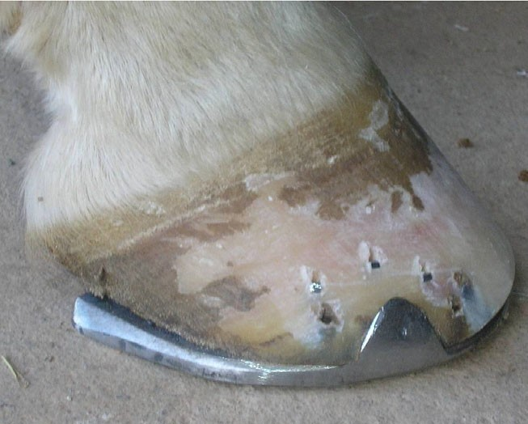

Fig 1: Red arrow shows the ﬁrst interface between the hoof and the shoe. The blue arrow shows the second interface between the shoe and the ground.
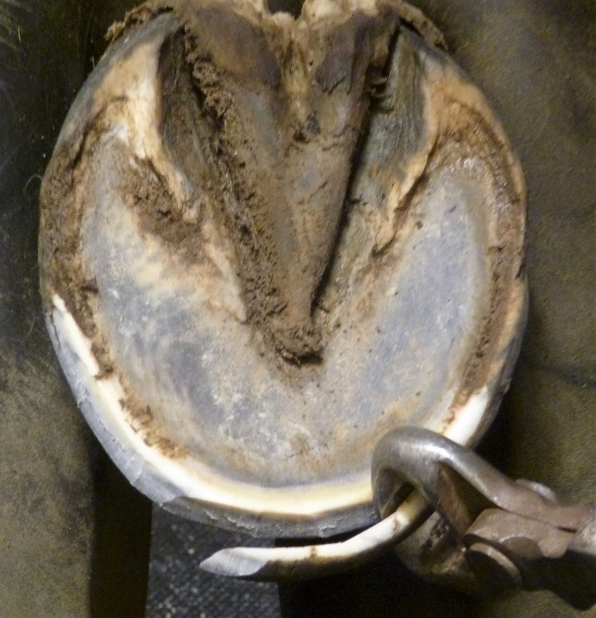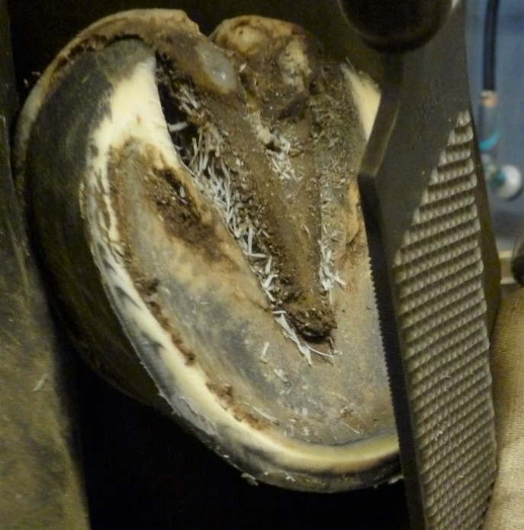Fig. 2 Nippers being used at a vertical angle starting Fig. 3 Rasp being used on a 45° angle dorsal to the cut dorsal to the white line. This will create a thin the white line. Note the mound of hoof wall mound of hoof wall and a thin white line (red arrow) (3-5 mm) being formed and again the thin on the bearing border of the foot white line (red arrow) around the perimeter.
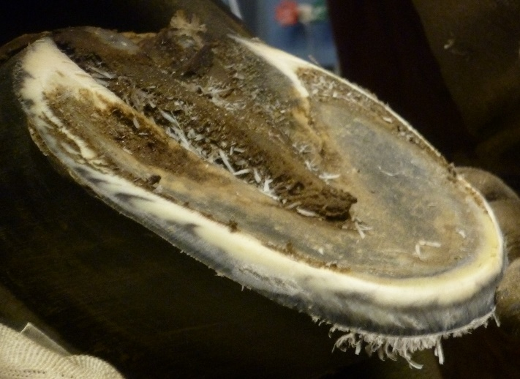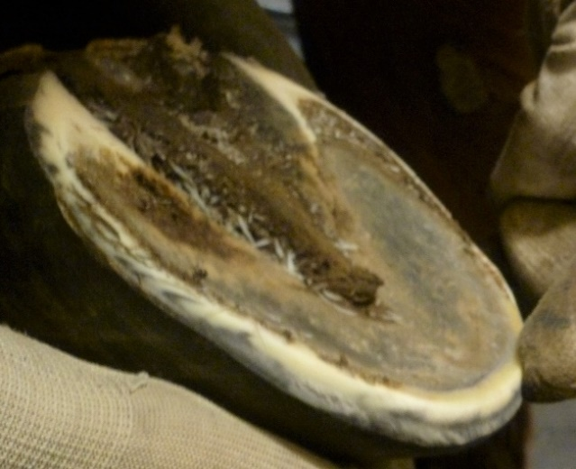Fig. 4A & 4B A shows the sharp edge created when using the rasp vertically. B shows the thick rounded perimeter created by using the rasp against the outer hoof wall to remove the sharp edge.
B
A
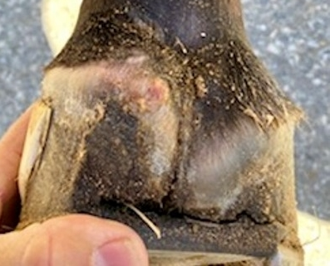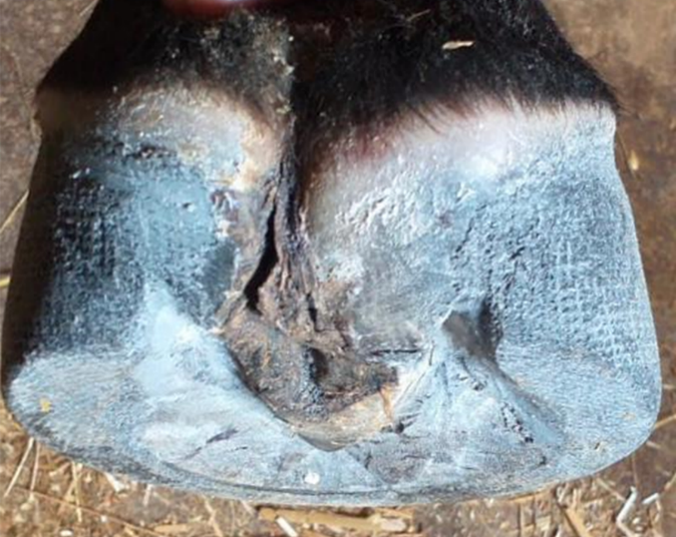Fig. 5A & 5B A shows a case with a sheared heel with an infected quarter crack which is draining at the heel bulb. B shows the same foot one week after the shoes had been removed and the heels trimmed as described in the text. A modified hoof cast was applied to stabilize the hoof wall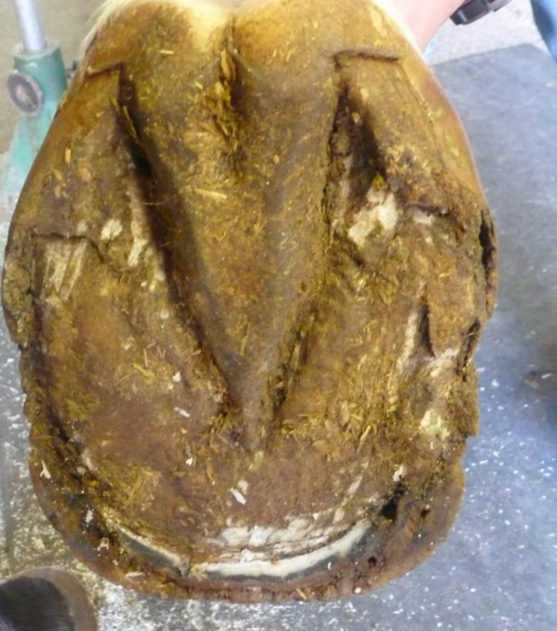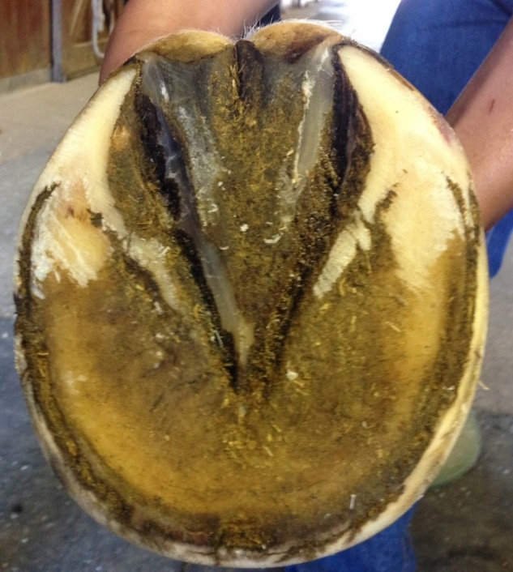 Fig. 6A & 6B A shows a foot with underrun heels and a prolapsed frog below the level of the hoof wall. The toe length was reduced, and the horse was handled as described in the text. At 10 days the frog was on the same plane as the heels and the heels could be trimmed. B shows the same foot 4 weeks later. Note the improvement in the heel base.
A
B
A
A
B
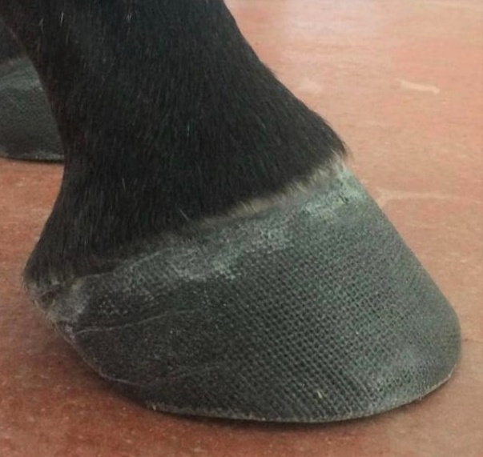 Fig. 7A&97B Lateral and solar view of a modified hoof cast. On the solar view, note the layer of cast around the perimeter of the hoof wall and the palmar section of the cast removed so the cast does not interfere with the physiology of the foot.
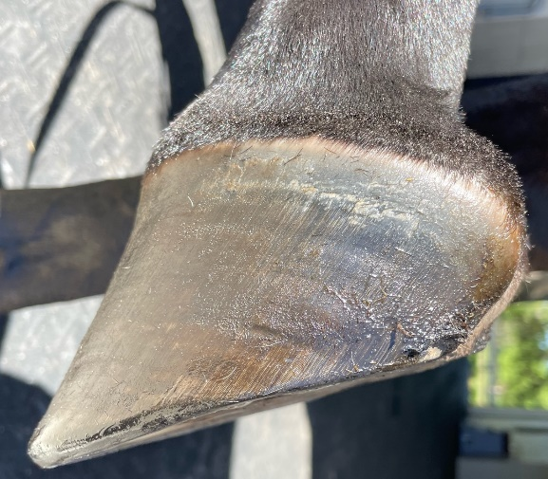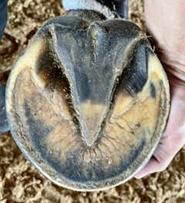 Fig 8. This is a foot from a competition horse that is in full work. Lateral view shows very nice hoof conformation. Note the sole callus at the toe, the thick broad frog, and the depth concavity of the foot.

