The Equine Foot: Form and Function
Stephen E. O’Grady, DVM, MRCVS
Author’s address—Virginia Therapeutic Farriery 833 Zion Hill Rd, Keswick, VA 22947; e-mail: sogrady@look.net

introduction
T

HE foot is interesting and unique as it is a group of biological structures that follows the laws of biomechanics (Fig. 1). It is also the authors’ opinion that the foot is also the dominant site of lameness in performance horses. Therefore, every time farriery is performed on a horses’ foot, the form and function of the foot will be affected. The digit is that part of the limb distal to the metacarpophalangeal joint. The foot is the part of the distal limb encased by the hoof. The hoof (ungula) is, by definition, the integument or skin of the foot. The hoof capsule is formed by the cornified layer of the epidermis in the various regions of the hoof.

Form
The gross morphologic differences between the distal limb and the rest of the musculoskeletal system cause some intimidation. However, to overview the distal limb as a cause of lameness, there are only so many structures in the foot and
there are only so many pathological processes that may occur in each structure. The acronym ‘DAMNIT’ which stands for degenerative, anomalous, autoimmune, metabolic, nutritional, neoplastic, inflammatory, infectious, and traumatic could be used to demonstrate this concept. By understanding how these structures function normally and considering all the potential processes that may occur, a specific diagnosis may become more readily apparent or the diagnostic puzzle can be reduced through the process of elimination. Furthermore, a thorough knowledge of foot anatomy and the associated biomechanics provides concise guidelines for applying the appropriate farriery to any given foot. These guidelines can be used to maintain the health of the foot or can be applied to address a pathological process.¹⁻³

The proximal and middle phalanges are structurally unremarkable compared to the long bones of the limb. They are flattened cylinders, more so palmar /plantar than dorsally with well-demarcated cortices and medullary cavities. The distal phalanx however is unique. It has three surfaces: the articular surface, the parietal surface and the solar surface. The parietal surface forms a large surface area that is porous and

roughened – ideally adapted for a broad attachment to soft tissue and to allow vessels to penetrate.

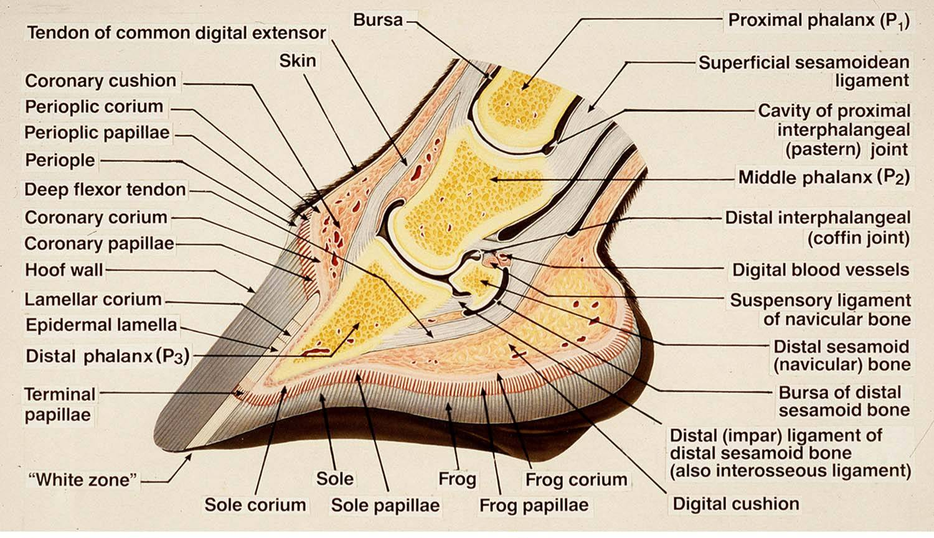
Fig 1. Schematic illustration showing the biological structures of the foot along with the biomechanical properties focused at the distal interphalangeal joint. Courtesy of Dr Chris Pollitt.

The solar surface is hard and smooth with no vascular foramina. Attached to the palmar process of the distal phalanx are the collateral (ungual) cartilages. These cartilages are flat rhomboid plates in a shape that extend proximally from the palmar process so that approximately 50% of each cartilage is proximal to the coronary band. The ungual cartilages could be thought of as an extension of the distal phalanx. Both interphalangeal joints are saddle joints such that motion is primarily restricted to extension and flexion in the sagittal plane but this configuration also allows considerable counter-rotation in the frontal plane. The distal interphalangeal joint has a much greater range of motion than the proximal interphalangeal joint. The distal interphalangeal joint has three separate articulations: 1) between the middle and distal phalanges, 2) between the middle phalanx and the distal sesamoid bone, and 3) between the distal phalanx and the navicular bone. There is very little movement between the distal phalanx and the distal sesamoid, so they are frequently treated as one unit and should be considered as moving together.⁴

The articular surfaces of the phalanges of both interphalangeal joints are maintained in apposition by paired collateral ligaments. In the proximal interphalangeal joint, the palmar aspect of the joint is supported by the proximal scutum and the flexor tendons along with and 2 pairs of abaxial and axial palmar ligaments. In the distal interphalangeal joint, the position of the distal sesamoid bone is stabilized and held in place by the paired collateral ligaments of the distal sesamoid proximally and the impar ligament distally (Fig. 2). The wide expanse of the deep digital flexor tendon supports the distal interphalangeal joint palmarly (Fig. 3). In addition to these ligaments, there are 5 small ligaments and peri ligamentous/ tendinous fibers associated with each ungual cartilage.

It is the integument of the foot that really separates the foot apart from the rest of the musculoskeletal system.³ Like the skin, the integument of the foot (hoof) is composed of 3 principle layers: epidermis, dermis (corium), and subcutaneous tissue. Like the skin, the epidermis is further subdivided into layers: the stratum basale and the stratum spinosum, which are collectively known as the stratum germinativum, and the stratum corneum. The stratum corneum forms the hoof capsule.

Unlike the skin, which is relatively uniform over the surface of the body, the hoof can be divided into 5 distinct regions based on their gross appearance: coronary band, wall, sole, frog and heel bulbs. Underlying the hoof, the germinal layers of the epidermis, the dermis and the subcutaneous tissues are highly specialized and are named after the tissues they generate or support: perioplic (limbic), coronary, lamellar, solar and cuneate (frog). The terms used to describe the region and epithelial types are not necessarily interchangeable because the surface does not necessarily reflect the type of underlying epithelium.

The limbus or periople is a narrow band of modified skin that bridges the gap between the skin of the pastern and the coronary band, and forms the stratum externum of the hoof wall. The corona is the band like proximal segment of the hoof frequently called the coronary band. The coronal subcutaneous tissue forms the coronary cushion, the coronal dermis follows the curve of the coronary cushion from which the dermal papillae project and the germinal layers of the coronary epithelium, which follow the contour of the dermal papillae, generate the tubular and intertubular horn of the stratum medium of the hoof capsule.

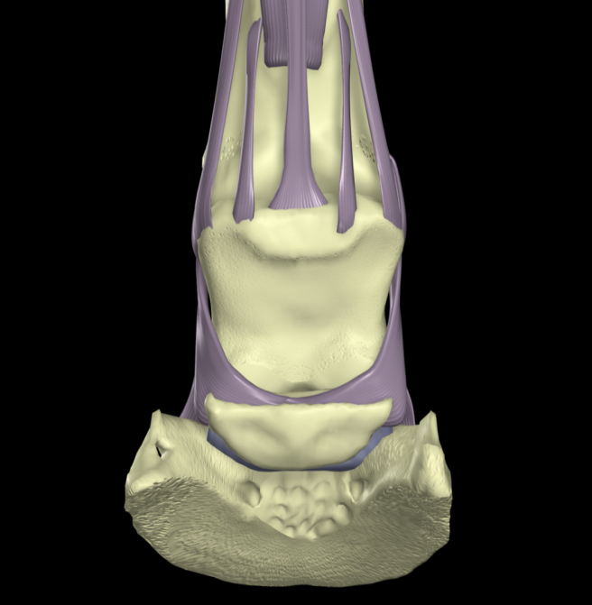
Fig. 2 shows the two pairs of palmar ligaments that span the proximal interphalangeal joint and the three ligaments that maintain the position of the navicular bone in relation to the distal interphalangeal joint.

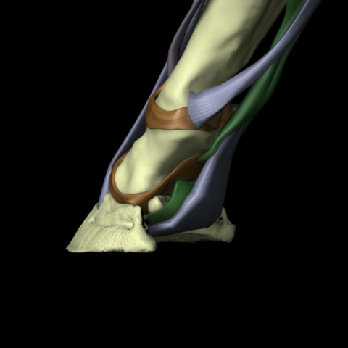
Fig. 3 shows the wide expanse of the deep digital flexor tendon. The tendon forms a sling into which the distal phalanx descends during weight bearing which will function as a shock absorbing mechanism. Its functionality will be base on the integrity of the structures in the heels of the hoof capsule.

The laminar integument covers the parietal surface of the distal phalanx and the ungual (collateral) cartilages. The laminar subcutaneous tissue forms the modified periosteum or perichondrium that covers the distal phalanx and ungual cartilages. The lamellar dermis forms the primary and secondary ridges that run in a proximal to distal direction to form lamellae that interdigitate with the epidermal lamellae. The primary epidermal lamellae are keratinized, the secondary lamellae are not. The lamellar epidermis forms the stratum internum of the hoof wall. The solar integument covers the solar surface of the distal phalanx. The subcutaneous tissue likewise forms the modified periosteum of the solar surface of the distal phalanx, the dermis forms the dermal papillae and the overlying epithelium forms the tubular and intertubular horn of the sole.
The cuneate integument forms the digital cushion from the subcutaneous tissue, the dermis, the dermal papillae, and the epidermis, the tubular and intertubular horn of the frog. The cuneate integument differs from that of the sole in gross appearance, in texture and because there are occasional adnexal structures arising from the epidermis.

The hoof capsule is viscoelastic; that is, when subjected to a sudden high stress, it deforms elastically. In contrast, when subjected to a constant stress it deforms slowly in a viscous manner which will generally reverse when the stress is removed.³ In fact the hoof wall is so resistant to sudden high stresses that it is considered more fracture resistant than bone.

Function

The distal limb is functionally a set of levers and pulleys. In the standing horse, the weight (mass x acceleration of gravity) borne by the limb is supported by the ground, which opposes the weight with an equal and opposite force. This force exerted on the hoof by the ground is termed the Ground Reaction Force (GRF). At rest both of these forces are approximately vertical. The mechanical interaction between the horse and the ground has been measured with force plates that do not differentiate between weight-bearing by different parts of the foot, but renders a single value. It is represented as a vector (GRFV).^{5,6} Vectors have a direction and magnitude. This vector represents the summation of all the forces acting on the foot. Measurements made this way can be broken into three components representing the three orthogonal planes, vertical, dorsopalmar, and mediolateral. As such they have a point of action generally referred to as the center of pressure. The center of pressure can be manipulated to some extent through farriery.

The weight of the body supported by the limb is transmitted through the limb by the skeletal system. Based on clinical evidence, it has been assumed that the lamellae suspend the distal phalanx within the hoof capsule. In horses with laminitis in which the lamellae are severely damaged, the distal phalanx displaces within the hoof capsule. Additionally, it is possible to remove the majority of the sole in horse for therapeutic reasons and the horse is able to bear weight on the wall without the distal phalanx displacing. While, it is not possible to measure where the force is going within the tissues of the hoof capsule and lamellae, this has been modeled with finite element analysis, which supports the intuitive position.⁷ When the weight is spread over the center of the ground surface of the hoof, it indicates that the forces associated with weight bearing are directed to the wall through the sole, and then through the lamellae.⁷

The center of pressure varies between horses, but is approximately in the center of the ground surface of the foot (Fig. 4). This is dorsal to the center of rotation of the distal interphalangeal joint.⁶ The force exerted through the skeletal system is acting through the center of rotation of the distal interphalangeal joint. Therefore, the GRF creates a moment about the distal interphalangeal joint. A moment is the tendency to cause rotation of a body about an axis. This moment created by the GRFV will cause the joint to dorsiflex (hyperextend) if unopposed; this moment is termed the extensor moment. In this case, the axis is the center of rotation of the distal interphalangeal joint. The magnitude of the moment is the product of the force and the length of the moment arm. The length of the moment arm is the shortest distance between the line of action of the GRFV and the center of rotation of the DIPJ (i.e. the moment arm is perpendicular to the line of action of the GRF). Because the foot is in a stable position flat on the ground, the extensor moment must be opposed by an equal and opposite moment, which is the flexor moment. The flexor moment is the product of the force in the deep digital flexor tendon and the length of the moment arm, which is the shortest distance from the center of rotation of the DIPJ to the tendon (Fig. 3).

In motion, the weight borne by the limb, the position of the foot, the joint angles of the phalangeal axis and the tension in the flexor tendons are constantly changing. The stride can be divided into 4 phases: Impact/Landing, horses usually land heel first or flat footed; Stance / Support phase, the foot is flat on the ground; Breakover, the heel is no longer in contact with the ground, but the toe is; Flight/Swing phase, the foot is off the ground.

Fig. 4. At rest the ground reaction force (grey arrow) is dorsal to the center of rotation of the distal interphalangeal joint. As such it creates an extensor moment that is opposed by an equal and opposite moment, the flexor moment, generated by the force in the deep digital flexor tendon so that the foot is stationary. Courtesy of Dr Andrew Parks.

During the landing phase and the first part of the stance phase, the mass of the body is accelerating towards the ground. To decelerate mass of the body as it descends to the ground (and also breaks forward momentum) as the foot lands
and bears weight several events occur. The fetlock dorsiflexes, and the DIP and PIP joints flex (the latter only slightly), so that the fetlock drops towards the ground as the tendons absorb and store energy. The distal phalanx rotates slightly within the foot about its dorsal solar margin so that the palmar processes move towards the ground. The articulation between the distal phalanx and navicular bone opens up. The hoof expands (the exact mechanism is unknown). During the second half of the stance phase and the breakover phase the horse must be accelerated forwards and the limb lifted off the ground. Contraction of digital flexor muscles and release of stored energy in the tendon and inferior check ligament, flex the fetlock, and extend the DIP and PIP joints. As the hoof acts as an extension of the distal phalanx, the leverage about the DIP joint may change.

During the flight phase, the distal limb flexes and then extends to prepare for landing as it is protracted. Proprioceptive receptors appear to determine the angles of the joints in preparation for impact with the ground. The way the foot impacts the ground is described as dynamic balance. A horse is said to be in dorsopalmar dynamic balance when the foot lands flat. A horse is said to be in mediolateral dynamic balance when the foot lands with both heels simultaneously. Unfortunately, this does not take limb conformation into consideration.

Foot Conformation

In addition to discussing the individual elements of the distal limb it is necessary to discuss how they relate to each other which could be termed foot conformation. In the resting horse, these relationships can be examined by viewing the foot
from the lateral, dorsal and solar aspects.

From the lateral aspect, the foot pastern axis should form a straight line. There are ideal lengths for the foot-pastern axis and the ground surface of the foot that have been described.¹ In addition, a vertical line that bisects the third metacarpal should intersect with the ground at the most palmar aspect of the weight bearing surface of the hoof wall. When these three are taken together, it is evident that there is a triangular relationship between the length and angle of the foot pastern axis, the location of the third metacarpal and the length of the foot, which should hold regardless of the size of the horse. This relationship defines static dorsopalmar conformation (Fig. 5A).

When viewed from the dorsal aspect, the axes of the metacarpus and pastern are in the same plane. A vertical line that bisects the metacarpus and pastern should be perpendicular to a horizontal line drawn between any 2 comparable points on the coronary band or the ground surface of the wall. The medial wall of the foot may be slightly steeper that the lateral wall. Growth rings should be equally spaced around the circumference of the foot. This relationship defines
static mediolateral conformation (Fig. 5B).

When viewed from the solar surface of the foot, the medial and lateral sides should be approximately symmetrical about a line bisecting the frog. The length of the foot should approximate the width. The frog width should be 60-70% of the frog length (Fig. 5C).

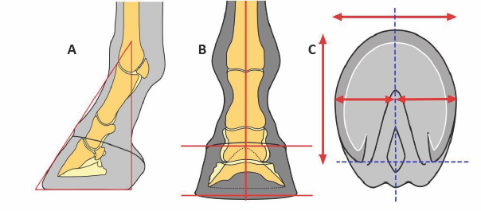
Figs. 5A-C. 5A shows a triangular relationship between the length and angle of the foot pastern axis, the location of the third metacarpal and the solar surface of the foot. 5B shows a vertical line that bisects the metacarpus and pastern that should be perpendicular to a horizontal line drawn between any 2 comparable points on the coronary band or the ground surface of the wall. 5C shows the solar view of the foot, the medial and lateral sides should be approximately symmetrical about a line bisecting the frog. The length of the foot should approximate the width. Courtesy of Dr Andrew Parks.

Conclusion

The farriery and veterinary professions have made significant advances over the last 25 years relating form, function and biomechanics to routine and specialized foot care. Although biomechanics have not been covered extensively in this discussion, it is easy to see how a thorough knowledge of foot form (anatomy) and foot function (how the structures relate to each other) could be used as consistent guideline to apply appropriate farriery on an individual basis. Many new methods/techniques have evolved in the practice of farriery yet the anatomical structures and function of the foot have remained the same; therefore the form and function of the equine foot can be used to direct your clinical decisions in the majority of foot cases.

References

- O’Grady SE, Poupard DE. Proper Physiologic Horseshoeing. Vet Clin North Am Equine Pract 2003;19:2:333-344.
- Hickman J, Humphrey M. (Eds.) Hickmans Farriery 2nd edn. J.A. Allen London 1988;136-175.
- Parks AH. Form and function of the Equine Digit. Vet Clin North Am Equine Pract. 2003;19:2:285-296.
- Denoix J. Functional anatomy of the equine interphalangeal joints, in Proceedings. Am Assoc Equine Pract 1999;45:174-177.
- Eliashar E. An evidence-based assessment of the biomechanical effects of the common shoeing and farriery techniques. Vet Clin N Am-Equine 2007;23:425–442.
- Parks AH. Aspects of Functional Anatomy of the Distal Limb, in Proceedings. Am Assoc Equine Pract 2012;58:132-137.
- Thomason J, McClinchey H, Jofriet J. Analysis of strain and stress in the equine hoof capsule using finite element methods: comparison with principal strains recorded in vivo. Equine Vet. J 2002;34:719–725.

